**Game - based activities in learning process**

**Bosmos Fotios**

Department of Informatics and Telecommunications, University of Ioannina, Arta, Greece

mposmos@yahoo.gr

**Abstract**

This study presents ways to utilize activities with game elements in the educational process. Initially the theoretical background of the object of our research is presented. More specifically the effect of game activities on reducing anxiety in a learning environment is presented. Moreover, researches related to the basic principles that must be observed when designing a game-based educational activity and when using it in learning is recorded. In our research, through an example of a digital quiz that incorporates assessment and self-assessment elements, the effectiveness of game activities when they complement learning is emphasized. Finally, the contribution of such activities to creating a lighter and more pleasant climate in the classroom is highlighted, which refers to familiar recreational environments for students from their everyday lives.

**Keywords:** Gaming, Learning, Participation

**Introduction**

Gaming as a means of entertainment is available to people from an early age. Beyond its entertaining character, it also contains educational elements that play an important role in the learning development of children. Modern education is called upon to incorporate more familiar practices to students, which transform the learning process from formal to a creative and innovative process that attracts the interest of children and at the same time utilizes experiential elements from extracurricular life.

Over time, gamification has evolved into a rapidly growing field of research with broad applications in the design of information systems in various fields, such as education, healthcare, and marketing. Gamification plays a key role in enhancing user engagement and involves the design of systems, services, organizations, and activities that aim to provide positive experiences, similar to those offered by games, thereby influencing users' behavior and cognitive processes (Jia et al., 2024).

This research studies the learning elements contained in the game through the creation and use of specific gaming activities as well as their degree of acceptance by students, in order to make the learning process and the school experience more effective and enjoyable.

Through a specific example of creating and using a digital Kahoot! quiz in a secondary education IT course, the aim is to identify and document the basic design principles and the impact of digital quizzes on the learning process, and in particular on the element of fun through learning as well as on the element of evaluation and self-assessment. Through this specific case study use, the possibility of using similar gaming activities in other lessons such as history, literature, arts, culture, music and others is highlighted. At the same time, through the possibility of individual and at the same time participatory response, the effectiveness of digital quizzes in collaborative learning is documented.

**Theoretical background**

*The impact of games in learning*

In recent years, gamification has attracted the interest of professionals and researchers, as it offers a way to achieve various emotional, cognitive and social goals, while guiding people's behavior with the aim of promoting innovation and productivity (Blanco et al., 2023).

In education, a major challenge is adapting teaching methods to students’ needs. This allows students to progress at their own pace, participate in discussions with their peers through online tools, and enables teachers to gain information about students’ difficulties and strengths (Alt, 2023). The learning process becomes more interesting and engaging, enhances students’ enthusiasm, promotes their initiative, and contributes to better memory and understanding (Fu et al., 2024). Furthermore, when students are enthusiastic about their studies, they are more likely to memorize information (Nair, 2022).

Gamification-based learning enhances familiarity with the content and increases performance expectations, events that directly influence knowledge acquisition (Alt, 2023). Overcoming the various levels and challenges encourages players, which can enhance their satisfaction, making them feel that they are actively participating in the experience. This can be achieved either through narrative or through rewards, elements that are crucial to the game experience (Murillo-Zamorano et al., 2023).

For example, after evaluating the results of a digital game designed to promote numeracy skills in primary school students, it was found that the game had a positive effect on various types of numeracy skills and knowledge (Alt, 2023). The phenomenon of creating game-related experiences can be linked to aspects that are embedded in human behavior, such as pleasure (Liu et al., 2024). In addition, games often offer the possibility of interacting with others, which can help reduce feelings of isolation and loneliness that often accompany symptoms of anxiety (Alsswey& Malak, 2024).

*The impact of gaming on stress management in learning*

Anxiety is a common issue that affects, among other things, the learning process. It is associated with a variety of symptoms, such as physical reactions that include sweating, trembling, fainting or dizziness, as well as psychological difficulties such as inability to concentrate, increased heart rate, feeling overwhelmed, sleep problems, difficulty focusing on tasks, inability to make decisions, etc. Anxiety symptoms can have a negative impact on the learning process. For example, physical symptoms of anxiety may prevent concentration and focus on a task, resulting in reduced learning performance. In addition, they can cause difficulties in memorizing information and assimilating new knowledge. In addition, feelings of anxiety and fear can often cause procrastination or even avoidance of tasks that are considered difficult. For this reason, it is crucial to create a supportive learning environment for students so that tasks seem more manageable (Alsswey& Malak, 2024).

One of the elements that has helped reduce anxiety is the filming or recording of lessons. This allows students who are taking lessons later, e.g. via a platform, to gain more confidence to comment, ask questions or participate in discussions in the course forums. Thus, they have the opportunity to expand the learning process beyond the physical classroom (Natalia et al., 2024).

Other research has shown that gamified learning, with tools such as Kahoot! digital quizzes, can lead to a reduction in anxiety symptoms. This is consistent with the findings of other studies, which have shown that gamification can be an effective means of reducing anxiety symptoms (Alsswey& Malak, 2024).

The main elements of a game, such as rewards, grades, levels, and leaderboards, can also contribute to reducing anxiety symptoms by offering students a constant sense of control and accomplishment (Alsswey& Malak, 2024). Users who receive, for example, virtual medals and official certificates usually feel more satisfied (Bi et al., 2024).

Creating enjoyable tasks or activities that encourage the user to focus on something other than what usually causes them stress can also significantly contribute to coping with emotions related to fear, such as fear of failure or fear of the unknown (Alsswey& Malak, 2024).

The most effective teaching methods are those that align with learning objectives while also taking into account the students’ perspective (Lee, 2023). In addition, the effect of gamification on active student participation is highlighted. Participating in competitive challenges creates pleasure and enhances user engagement. At this stage, attention is focused on the connection between engagement and knowledge, as it has been observed that there is a positive correlation between engagement in the learning process and knowledge acquisition (Murillo-Zamorano et al., 2023).

*The contribution of games to creating motivation*

Courses often utilize interactive and experiential platforms to facilitate the delivery of theoretical knowledge. However, some major problems associated with online courses include lack of motivation, social isolation, reduced student engagement, distractions, lower attention span, and ultimately a weak learning experience. These issues can be effectively addressed if the course content and presentation are designed in a creative manner (Nair, 2022).

Several studies offer evidence on the benefits of gamification in improving the quality of online courses, affecting factors such as student engagement and participation, motivation, creative learning experience, etc. These assumptions are useful for educators and educational policy makers in order to develop innovative and engaging learning activities, as well as to prepare digitally and professionally competent graduates who will be able to serve sectors such as tourism (Nair, 2022).

Gamified practices, although not games, are designed to exploit human psychology in a similar way to games. The use of games in environments traditionally considered non-gaming, such as education, is one of the main goals of gamification (Aguiar-Castillo et al., 2021). When gaming elements are incorporated as a well-designed and executed experience, they act as factors that enhance student motivation and satisfaction (Murillo-Zamorano et al., 2023).The motivation of each student is considered a crucial element of the educational process. This is due to the significant impact that motivation has on learning, both in the process itself and in its results. (Aguiar-Castillo et al., 2021).

Motivations can be either intrinsic or extrinsic. Some students choose to study for the pleasure that knowledge gives them or to satisfy their desire to learn, while others have a specific reward in mind, such as a good job or financial benefits (Nair, 2022). Researches present the dual approach that results from the distinction between intrinsic and extrinsic motivations. The psychological dimension of these elements can be understood through two distinct characteristics: intrinsic, where a behavior or action is performed due to its connection to an internal value, and extrinsic, where external rewards, such as money or social status, are offered in exchange for a specific behavior (Aguiar-Castillo et al., 2021).

Furthermore, another study identifies four important capabilities of gamification (competitiveness, success, interactivity, and self-expression) that contribute to the achievement of external goals by activating users' intrinsic motivations (Liu et al., 2024).

Intrinsic motivation comes from within people and motivates individuals to act for the sake of the activity itself. In contrast, extrinsic motivation comes from factors outside the individual and leads to actions that offer rewards or help achieve other goals, acting as a means to achieving their purpose. In fact, when designing an application, it is critical to use incentives, both intrinsic and extrinsic, in order to enhance the likelihood of achieving the desired behavior (Aguiar-Castillo et al., 2021).

*Gaming in personalized and collaborative learning*

Humans, as rational beings who methodically analyze available information, utilize their knowledge to shape their intention to exhibit or avoid a specific behavior. The alignment of an instructor's teaching style with students' expectations is a critical factor in the learning process (Kauppinen & Choudhary, 2021).

As more and more games leverage AI technology, gamification offers personalized experiences that significantly impact the individual learning process. Compared to traditional approaches, game-based activities make it easier to assess and support each individual (Nair, 2022).

Gamification-based education should be designed to support personalized learning, as each student has a unique learning style and ability level. When designing a gamified educational process, the diversity of students in learning or other backgrounds should be taken into account. By providing personalized learning paths and challenges that reflect their individual differences, students can more effectively meet their learning needs and enhance their motivation to learn. Personalized learning design can include a variety of learning content, different difficulty levels, and teaching methods for each lesson, as well as adjustments and optimizations based on student progress and performance. This design allows each student to progress at their own pace, facilitating the comprehension of knowledge (Fu et al., 2024).

Gamification has been shown to promote acceptance of diversity and enhance inclusion in the classroom, as demonstrated by studies in various multicultural and multilingual classrooms. Education that promotes acceptance of diversity, including all students and striving for equality, is crucial to creating an inclusive environment and society. The term “education for diversity” refers to the process of recognizing and accepting different aspects in school classrooms. Inclusive education presupposes acceptance of this diversity (Nair, 2022)

In addition, personalized learning can lead to enhanced collaboration and communication among students, giving them the opportunity to learn from each other and encourage each other during their participation (Fu et al., 2024).

The use of gamification can contribute to changing behaviors within the classroom. Specifically, it can enhance students’ interest, active participation, and engagement in the learning process. It can also enhance the participation of less active students. In other words, gamification promotes engagement, which, in turn, contributes to improving the knowledge acquisition process (Murillo-Zamorano et al., 2023). The possibility of interactivity enhances social relationships and a sense of belonging, facilitating interactions and communication with others through tools such as messaging and dialogues (Liu et al., 2024).

Gamification elements, such as storytelling and role-playing, stimulate curiosity and promote engagement, encouraging users to participate in self-directed activities. At the same time, social elements of the game, such as conversation, sharing, and interaction, enhance communication and community building, thus strengthening the sense of belonging of users (Bi et al., 2024).

*Designing a game – based learning activity*

The design of game-based education should ensure that the elements of gamification are inextricably linked to the learning objectives, in order to ensure that students can achieve the desired learning outcomes (Fu et al., 2024).When designing learning and assessment activities, educators should consider a variety of learning activity options that challenge students (Alsofyani, 2023). There are a number of game processes that need to be designed that are critical to enhancing each student’s motivation (Aguiar-Castillo et al., 2021). Game-based education should offer immediate feedback and incentive mechanisms so that students receive positive recognition and rewards when they complete tasks or achieve specific goals, thereby enhancing their learning motivation and enthusiasm (Fu et al., 2024).

By introducing game elements and mechanisms, such as reward systems and role-playing games, it is sought to enhance students' interest and motivation for learning in order to improve their learning outcomes. This approach can make the learning process more lively and attractive, allowing students to acquire knowledge and develop skills in a pleasant and relaxed environment. Immediate feedback can support students in accurately understanding their learning status and level, allowing them to timely adjust their strategy, correct their mistakes, and maximize learning outcomes (Fu et al., 2024).

Key features of gamification include levels, points, leaderboards, avatars, missions, graphs, and other elements (Bi et al., 2024). Points allow players to track their progress, providing satisfaction, while the dissemination of these to other players through leaderboards can lead to recognition (Murillo-Zamorano et al., 2023).

The game tools incorporated into gamified applications guide the user through a flow process, which, by its nature, encourages the learner to repeat behaviors that promote learning. Thus, a habit is formed as a result of gamification (Aguiar-Castillo et al., 2021). The educational method of gamification can offer a variety of difficulties and challenges, adapted to the different grades and abilities of students, allowing them to develop their skills through continuous efforts (Fu et al., 2024).

To this end, modern training programs should incorporate, as much as possible, the following principles: repetition (continuous practice), feedback (receiving frequent, immediate and reliable comments), adaptation (distribution of tasks according to the level of difficulty), conciseness (complex tasks structured into short and specific exercises that cover the general topic), freedom of choice (regarding the exercises and the order in which they are performed), as well as recognition and reward (awards and rewards) (Alt, 2023).It is also particularly important to determine whether the learning content and game elements are perfectly combined (Nair, 2022).

Emotional value is an important factor for individuals, and game designers should incorporate emotional elements, such as pleasure and flow mechanisms, to enhance participation in game activities. Thus, designers have the opportunity to increase player engagement by adding fun elements that transform daily routines into pleasant and exciting experiences, facilitating entertainment and enjoyment (Jia et al., 2024).

In addition, the design of game-based education should carefully consider the interests and abilities of students to ensure that game activities are appropriate to their cognitive development level. Teaching activities should be adapted to the cognitive development level of students. It is also necessary to avoid games that are too simple or too complex to ensure that students experience challenges in the learning process, as well as a sense of accomplishment (Fu et al., 2024).

Educational assessment processes and the provision of individual or even overall feedback are time-consuming and demanding. The use of gamification, such as through quizzes, offers significant assistance to educators in various ways (Nair, 2022). Kahoot! is an innovative learning platform that is redefining the way people acquire knowledge. Designed to enhance student engagement and motivation, this platform promotes more active participation and interaction with educational materials, encouraging students to invest more in the learning process. Kahoot! allows students to answer questions and compete with each other in a funny and engaging way. At the same time, it offers teachers a variety of options for customizing their quizzes, allowing them to create content that meets their specific needs. For example, they can incorporate images, videos or audio clips, as well as determine the level of difficulty of the quizzes, ensuring that they are appropriate for the students in their class (Alsswey& Malak, 2024).

Additionally, the app provides teachers with detailed information about their students’ performance. This information can be used to identify areas where students are struggling and to track their progress over time. A prime example is Kahoot!’s reward system, which offers points and notifications for completing tasks, as well as leaderboards that compare participants’ performance. This encourages friendly competition, motivating students to try harder and achieve better results. Kahoot! can also be used to design more effective lessons and provide personalized feedback to each student (Alsswey& Malak, 2024).

Students participate in the quizzes via their smart devices or computers, using pseudonyms. Their devices are connected to the quiz via a network. After recording students’ answers to each question, an important pedagogical benefit is that the game immediately displays the correct answers on the screen, allowing the teacher to explain them to the students (Kauppinen & Choudhary, 2021).

In Kahoot!, the application sets a default response time for each question, which can be modified by the instructor. After each game, instructors have the ability to obtain results reports, which are provided in spreadsheet format. These reports include information about each player’s performance, analyzing correct and incorrect answers (Kauppinen & Choudhary, 2021).

When using Kahoot! in the classroom, it is important to consider that it offers two types of scores for each participant’s performance: Kahoot! scores (where a high score results from answering correctly and quickly) and correct answers (where a high score results from simply providing a correct answer). The scoring factor that allows top-performing students to answer slowly to confirm the correctness of their answers, or to answer quickly in order to outplay their peers in the game, may also have negative consequences (Kauppinen & Choudhary, 2021).

**Our research: An example of using gamification in learning process.**

*Purpose of our research*

The purpose of our research is to identify and record the possibilities of integrating playful learning activities into the learning process. This is pursued through the use of a digital Kahoot quiz that contains game elements such as interaction, automation, reward, etc., which is used in the assessment and self-assessment process of students in junior High School. The students' opinion on the effectiveness of this digital resource in the lesson is then recorded in electronic Google format. What we seek to record is whether an innovative practice such as the above can be experienced by students as a more pleasant and entertaining experience. An experience that serves the cognitive and learning goals of a unit but is at the same time free from negative elements contained in the traditional learning process, such as the absence of participation of some students, lack of motivation, anxiety, indifference and others.

*Materials and Methods*

Our research presents findings from the use of a digital Kahoot quiz for the evaluation and self-evaluation of 56 junior High School students in a computer science lesson in 2025. The quiz was solved in the school's computer lab. An interactive whiteboard was used to display the questions, while the laboratory computers were used for the students' answers. Its content concerns basic knowledge regarding the use of the repeat command in the creation of geometric constructions through the Scratch visual programming environment. The Kahoot digital quiz contains basic gamification elements such as rewards, comments, completion time, participatory solving, final ranking, etc. During the implementation of the process, no technological problems were encountered that could arise from the low speed of the internet.

After completing the digital quiz, the students themselves evaluated the process by answering 12 questions in an electronic Google form to identify and record their degree of satisfaction with the course evaluation process through the digital quiz, the extent to which the process was referred to them as a more playful process rather than a traditional learning process, their motivation to achieve high performance, their intention to use such quizzes in other courses, etc.

After the introductory teaching of the concept of repetition through the creation of programs in Scratch and the deepening of the concept of repetition through appropriately structured activities for this purpose, the students visited the link of the kahoot.it website and solved the playful digital activity individually but while being present in a participatory group action among their classmates.

Initially, the home screen of the quiz was presented. The home screen shows its title given by the teacher, which is related to the section and the content of the questions (Figure 1). Students or players visit the kahoot.it page on their computers and enter the game pin.

.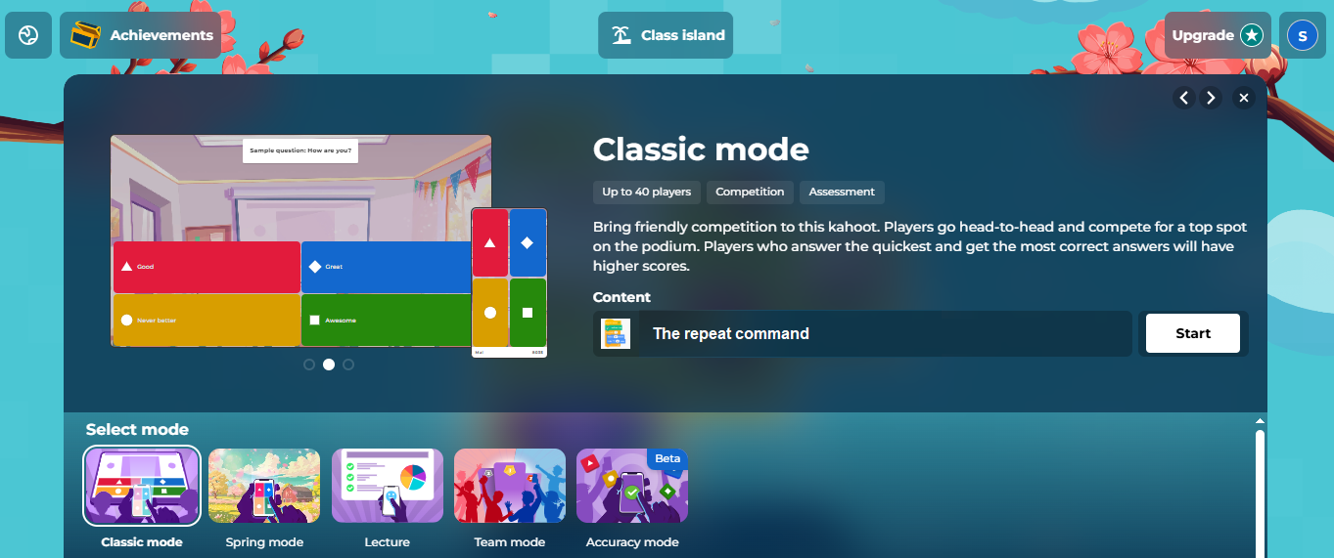

**Figure 1. The home screen of the quiz**

Then they are asked to create a nickname and choose their personal avatar from the kahoot application collection (Figure 2). The group of players is presented on the quiz screen shortly before the solving process begins. The questions are then presented sequentially.

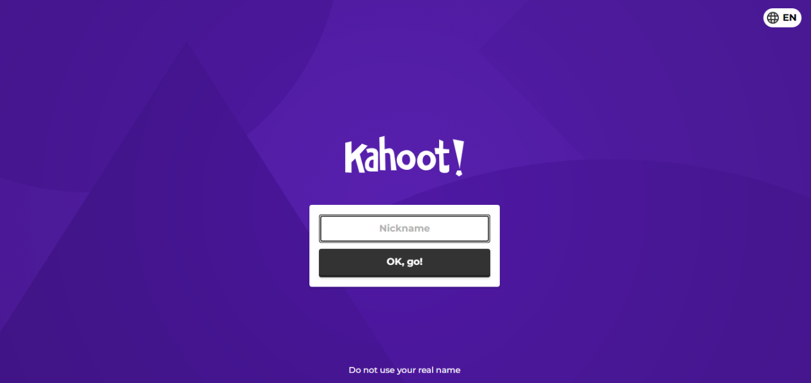

**Figure 2.Players create their nicknames**

Figure 3 shows a snapshot during the quiz solving process. As we can see in the figure, after each question, each player is presented with the points he earned in case of success. A corresponding message is also displayed in case of an incorrect answer, which contributes to the self-assessment of each student.

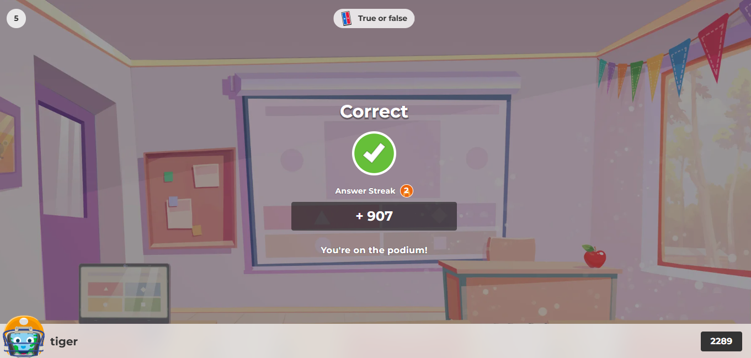

**Figure 3. Individual points earned from a student after their correct answer**

After completing each question, a graph is displayed with the number of total correct and incorrect questions by all players, which helps each student to see the level of their knowledge in relation to the entire class and the teacher to see the degree of acquisition of new knowledge by his/her students.

After the end of each question, the overall ranking of the group of players is presented in combination with the speed of the answer. The continuous rotation of positions as well as some messages from Kahoot regarding the performance of individual players that are presented to the entire class activate the players' motivation to become better in order to improve their position. Finally, the winners' podium with students’ animation is shown, as well as the players who came close to making it to the podium. Note that kahoot allows the teacher to create classes that solve each quiz.

Following the process after completing the quiz, students answered an electronic Google form anonymously and individually in order to submit and record their assessment of the entire process and the degree of acceptance of the digital quiz in learning progress.

*Evaluation and results*

The procedure for completing the electronic questionnaire is then presented and the statistical results are recorded. Regarding the axes of the questionnaire, there was an introductory section that explained the purpose of the research, information regarding the protection of the anonymity of the respondents and then the questions on the topic under investigation. The scale used allowed the participants to express their degree of agreement or disagreement with each question. Most multiple-choice questions had the options Not at all, Moderate, Quite, Much, Very much.

Regarding the validity of the questionnaire, the wording of the questions is adapted and understandable to junior high school students. The selection of the sample is objective as all the students who participated in the process have responded. The number of respondents is satisfactory for drawing safe conclusions that reflect the reality of the school classrooms. The answers of the questionnaire are presented in detail in the research part of this work.

Regarding the reliability of the research, it is high as students participated in the playful process in groups and evaluated it immediately after its completion. This fact indicates that the students' experience was recent and thus their answers were spontaneous and objective. Also, high homogeneity was observed in the students' answers by groups, which indicates greater reliability in drawing the conclusions of the research.

Regarding ethical issues, the participants took part in the process within the context of teaching Informatics courses and voluntarily answered the evaluation questionnaire. The answers were recorded anonymously and the personal data of the participants were protected. It was made clear that the findings of the research are used for educational purposes only.

The diagrams and statistical analysis of the students' responses are then presented. More specifically, Figure 4 shows their degree of satisfaction with the use of the quiz in the assessment of new knowledge. The vast majority (a total of 89.2%) find the use of the quiz in knowledge assessment Much and Very much satisfactory.

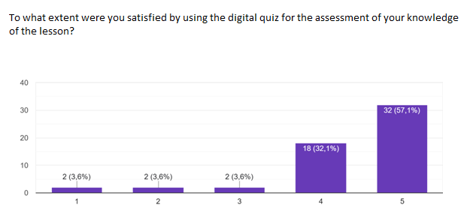

**Figure 4. The degree of student satisfaction from the use of the quiz in assessing new knowledge**

Figure 5 shows the extent to which the process of answering the digital quiz seemed to students funnier and more playful than the traditional lesson. A large percentage, 85.7%, found that the entire process referred to a Much and Very Much extent to a game process.

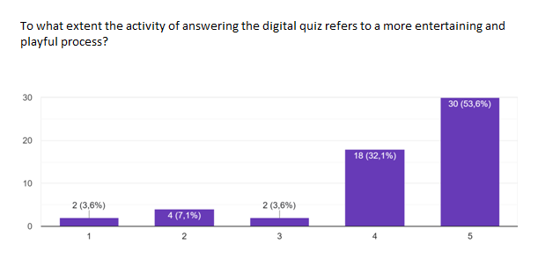

**Figure 5. The acceptance of the activity as a playful process**

Figure6 shows a graphical pie chart with the emotions that were created in the students throughout the process. It is important that half of them felt anguish while only 10.7% felt stress. A fairly large percentage of the students felt competition and curiosity.

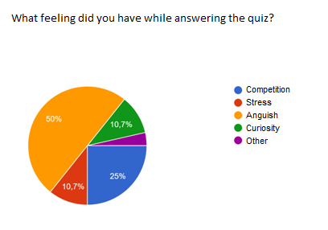

**Figure 6. The emotions during the process**

When students were asked whether they considered the existence of a time limit for answering each question to be positive or negative, 85.7% considered the existence of a time limit to be positive.

Figure 7 presents findings regarding the activation of students' motivation by the digital quiz. It depicts the respondents' opinion on whether the fact that if they answer correctly and quickly, they will earn more points makes them want to try answering the quiz again in order to collect more points this time. Τhe 82.1% say that to a Much and to a Very Much extent, they would like to answer the quiz again in order to collect more points this time.

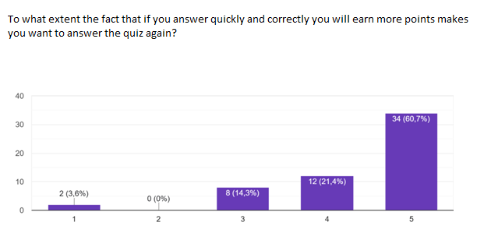

**Figure 7. Repetition of the quiz due to the fact that if they answer correctly and quickly they will earn more points.**

By recording the extent to which solving the quiz activates students' motivations to want to accumulate more points, more points than their classmates, and to win first place, we observe that their motivations in all three cases are activated to a Much and Very much degree at high percentages such as 82.1%, 89.2% and 82.2% respectively.

The following figures presents additional statistical pie charts related to the technical capabilities provided by Kahoot as well as the possibility of extending the use of digital quizzes in the learning process. More specifically, in Figure 8, respondents evaluate the operation of the application that shows a player the points he earns immediately after each correct answer. Approximately nine out of ten find positive the fact that they learn immediately if they answer correctly positive.

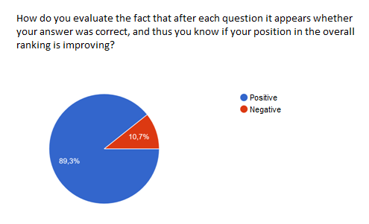

**Figure 8. Immediate display of points for each respondent**

It is also observed that 92.9% consider it positive that there is the possibility for someone to answer the quiz under a pseudonym, in order to maintain their anonymity.

A very large percentage of respondents (89.3%) in Figure 9 state that they would find it interesting to use similar quizzes in the assessment of knowledge in other courses.

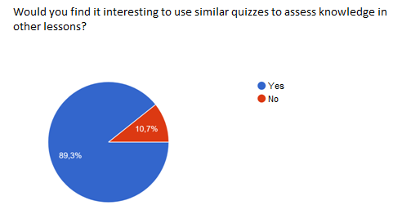

**Figure 9.Using quizzes in other lessons**

*Analysis and discussion*

What is recorded after the evaluation of the process by the respondents is that the acceptance of alternative ways of assessing knowledge in a teaching unit, for example through kahoot quizzes, is particularly popular. This is largely contributed by the fact that the process refers to a game and is more enjoyable and funnier for students. Procedures that students are used to following in a positive way, such as games, are the goal of educational policies for their integration into the classroom, as their acceptance by students also means acceptance of the educational process in general.

It is also important that such playful procedures do not create anxiety in students, but anguish, competition, curiosity and other emotions that they usually feel when playing. This fact seems to be led by the fact that there is a time limit for someone to answer a question. Besides, as emphasized by (Alsswey& Malak, 2024) overall, a significant reduction in stress symptoms was observed after using the games.

The fact that if someone answers correctly and quickly, accumulate more points is considered positive by students. Students' motivation seems to be largely activated to accumulate more individual points by answering the quiz again, which indirectly leads to a repetition of the key concepts of the unit.

However, competition is also stimulated as the process is not only individual but also participatory since the kahoot quiz is completed with all the students in the class. This is also demonstrated by the fact that the students' motivation is activated to accumulate more points than their classmates and to manage to take first place at some point. We conclude from the above that the involvement of all students in the lesson is stimulated as they now have clear individual goals.

Besides, as emphasized by (Nair, 2022) the elements of role-playing and competition add an engaging dimension that, when implemented correctly, makes learning more efficient and enjoyable. Fun enhances motivation, which has a decisive effect on what people learn, as well as how much of them they manage to memorize. If the process is enjoyable, students will maintain their curiosity and return for more knowledge.

A key factor in the acceptance of the integration of digital quizzes in learning is the fact that they receive immediate feedback from the application in case they answer correctly or incorrectly, as well as being informed about the points they earn from their general ranking. The correct answer here also brings a reward for a student which is required to encourage students. What teachers should be concerned with here is to include questions of various difficulty levels so that all students can succeed and be rewarded according to their knowledge. This way, the process, beyond being participatory, also acquires a personalized character.

Obviously,the fact that the students are given the possibility of participation using a pseudonym and an avatar, removes the fear of failure from the process since only they know their general ranking and only if they wish, they reveal their identity perhaps at the end of the process and after getting a good ranking or even a position on the podium. The points that students accumulate and their performance also help teachers evaluate the degree of assimilation of knowledge by their students and the degree of success of their lesson.

At a learning level, the kahoot quizzes can be used again and again by students to repeat basic concepts of a unit. They can also be used in other courses that do not have such a modern technological profile such as the more theoretical courses. After all, most classrooms have an interactive whiteboard with an internet connection and every teacher can use the school's computer lab to do their lesson, whatever it may be.

However, the existence of only one IT laboratory can be limiting for the generalized use of similar activities in all subjects. At the same time, responsible teachers should know how to design and use quizzes with pedagogical criteria and how to guide students in their response process.

Looking the future, some challenges of using gamification in the classroom should also be explored. For example, incorporating game elements into educational materials can have negative consequences for students, such as distracting them from the game elements (Alt, 2023). Future research should determine the optimal combination of traditional and gamified methods in order to improve learning while maintaining critical thinking and decision-making skills (Kim et al., 2024).

**Conclusion**

In conclusion, our research records the acceptance of modern methods that incorporate elements of gamification in the assessment and self-assessment of knowledge of students. A more relaxed and pleasant environment in the classroom helps students feel less negative emotions that they usually experience in the traditional classroom. After all, basic elements of games such as rewarding, collecting points, ranking, etc. activate motivations, interests and consequently the involvement of students in the lesson. However, teachers must design quiz questions with learning criteria that engage students of all levels and ultimately serve the objectives of learning.

**References**

Ahmed alsswey, Malakeh.Z. Malak, Effect of using gamification of “Kahoot!” as a learning method on stress symptoms, anxiety symptoms, self-efficacy, and academic achievement among university students, *Learning and Motivation,* 87 (2024).

Antti Kauppinen, Ali Iftikhar Choudhary, Gamification in entrepreneurship education: A concrete application of Kahoot!, *The International Journal of Management Education*, 19 (2021).

Bipithalal Balakrishnan Nair, Endorsing gamification pedagogy as a helpful strategy to offset the COVID-19 induced disruptions in tourism education, Journal of Hospitality, Leisure, *Sport & Tourism Education,*  30 (2022).

Chongwu Bi , Dandan Zhang , Zhuo Sun , Yan Jin , Ruixian Yang, Gamification effects in green behaviors: A double-edged sword, *Journal of Cleaner Production*, 483, (2024).

## Dorit Alt, Assessing the benefits of gamification in mathematics for student, gameful experience and gaming motivation, *Computers & Education* Volume, 200, (2023).

## Furong Jia, Xueqi Bao, Jie Yu , Gamification on digital platform: A *meta*-analysis of affordance on behavior from value perspective, *Electronic Commerce Research and Applications*, [68](https://www.sciencedirect.com/journal/electronic-commerce-research-and-applications/vol/68/suppl/C), (2024).

Lidia Aguiar-Castillo, Alberto Clavijo-Rodriguez, Lidia Hernandez-Lopez, Petra De Saa-Perez, Rafael Perez-Jimenez, Gamification and deep learning approaches in higher education, Journal of Hospitality, Leisure, *Sport & Tourism Education*, 29 (2021).

Luis R. Murillo-Zamorano , Jose Angel Lopez-Sanchez , María Jose Lopez-Rey , Carmen Bueno-Munoz, Gamification in higher education: The ECOn+ star battles, *Computers & Education*, 194 (2023).

Kun Fu, Zhen Liu, Xueyou Ren, Shenning Zhang, Design and research of educational mode in context of teaching gamification, *Entertainment Computin,*  50 (2024).

Kuo-Wei Lee, Effectiveness of gamification and selection of appropriate teaching methods of creativity: Students’ perspectives, *Heliyon*, 9 (2023).

Kyungha Kim, Daun Choi , Hoyoen Shim , Choung Ah. Lee, Effects of gamification in advanced life support training for clinical nurses: A cluster randomized controlled trial, *NurseEducation Today*, 140 (2024).

Mohammed M. Alsofyani, Eleven game elements for female nonadaptive gamification courses, *Heliyon*, 9 (2023).

Padilla-Zea Natalia, Verdu Elena, Baena-Galle Roberto, Gamification in technology and design areas: A teaching innovation project in a fully online environment, *Entertainment Computing*, 51 (2024).

Raquel Blanco, Manuel Trinida, Marνa Josι Suαrez-Cabal, Alejandro Calderon,Mercedes Ruiz, Javier Tuya, Can gamification help in software testing education? Findings from an empirical study, *The Journal of Systems & Software,* 200 (2023).

Xiaodi Liu , Zengze Zhou , Kum Fai Yuen , Xueqin Wang, Green and gamified! An investigation of consumer participation in green last-mile from a gamification affordance perspective, *Journal of Retailing and Consumer Services*, 79 (2024).