**Correlation between the vocabulary level and the psychosocial adjustment of children with Autism Spectrum Disorder (level 1)**

**Kastamoniti Dimitra**

Speech and Language Therapist, MSc, PhD

kastamonitidimitra@gmail.com

**Kafka Maria**

Speech and Language Therapist, M.Ed.

mariakafka.slp@gmail.com

**Kapogiannopoulou Chrysa**

Speech and Language Therapist, B.Sc.

chrysakapogiannopoulou@gmail.com

**Abstract**

Children with Autism Spectrum Disorder (ASD) level 1, primarily have difficulties with psychosocial adjustment. However, they often experience language deficits which have been associated with a decline in their social, emotional and academic competence, as well as with the presence of behavioral problems. The present study presents correlation data between the individual domains of psychosocial adjustment and the two types of vocabulary, perceptive and expressive. The research sample consists of 6 pre-school age children with level 1 ASD diagnosis, who were assessed in the two - under study - domains with standardized, in the Greek-language, tools. The results showed that there is a very strong correlation between perceptive vocabulary and social competence of children with ASD as well as between word definition ability and school competence. However, a strong negative correlation between behavioral problems and word definition ability was demonstrated.

**Key words:** receptive vocabulary, expressive vocabulary, psychosocial adjustment

**Introduction**

Children with Autism Spectrum Disorder (ASD), in addition to significant impairment in social interaction, verbal and non-verbal communication difficulties, as well as stereotyped and repetitive behaviors, also present notable difficulties in individual areas of psychosocial adjustment (American Psychiatric Association, 2013).

More specifically, with regard to language deficits, depending on the level at which a child with ASD is clarified, one or more language subsystems are affected. Focusing on the area of vocabulary, both receptive and expressive, conflicting literature has emerged. However, the majority of these, agree that both types of vocabulary fall short in this diagnostic category (Hojjati & Khalikhaneh, 2014).

Apart from the deficits in the two types of vocabulary that observed in children with ASD, there are also deficits in their psychosocial adjustment which includes social, emotional and academic competence, as well as the behavioral problems, that these children manifest (Nader-Grosbois & Mazzone, 2014).

Regarding the association between vocabulary domains and the individual domains of psychosocial adjustment, very little literature is reported. At the same time, the majority of them concern an English-speaking population and a wide age range. Consequently, the purpose of the present study is to investigate the correlation between the vocabulary level of children with level 1 ASD, at early school age, with the sub domains of psychosocial adjustment i.e. social, emotional and school competence, as well as the presence of behavioral problems.

**Conceptual definitions**

*ASD levels*

It is reported that ASD is divided into three subtypes, based on the severity of symptoms and the children’s need for support. Specifically, level 1 includes individuals who need mild support, level 2 includes individuals who need substantial support and level 3 includes individuals who need highly enhanced support (American Psychiatric Association, 2013). A further characteristic of children with ASD is impaired social communication functioning across the lifespan, which affects their emotional competence and thus, their adjustment to the school environment (Weiss et al., 2013).

*Receptive vocabulary*

A person’s receptive vocabulary is the set of words whose meaning he or she knows, and therefore understands (Maskor & Baharudin, 2016). In particular, children with a poor receptive vocabulary have difficulty in understanding complicated orders and sentences, as well as in combining information, in order to reach logical conclusions about a social situation (Archodi, 2017).

*Expressive vocabulary*

A person’s expressive vocabulary is the set of words whose meaning he or she knows and which he or she produces orally or in writing. It is a linguistic domain, like the receptive vocabulary, that continues developing throughout a person’s life. The interaction of perceptive and expressive vocabulary leads to the creation of a complete “picture” of words (Maskor & Baharudin, 2016).

*Psychosocial adjustment*

The psychosocial adjustment of a school-age child is determined by his or her levels of social, academic and emotional competence, as well as the behavioral problems he or she exhibits (Doobay, 2014· Hsiao et al., 2013).

Using the term “social competence”, we mean the development of behaviors and specific skills that enable the individual to function effectively within a social group, to meet social expectations and to be able to establish healthy social relationships (Ukasoanya, 2013).

Similarly, “academic competence” refers to a student’s ability to perform academic tasks effectively, understanding and applying knowledge and skills in various learning areas. In addition, a student who is proficient, is able to organize and manage his or her time to complete his/her tasks (Vestad et al., 2021).

In addition, the ability of a person to manage and use his or her emotions in a way that facilitates his or her social interaction, as well as his or her personal well-being, constitutes “emotional competence” (Mortazavizadeh et al., 2022).

“Behavioral problems” are defined as children’s unwanted and socially unacceptable behaviors. Behavioral problems are divided into externalized and internalized. Externalized behavioral problems include obvious behaviors such as aggression, while internalized behaviors include less obvious behaviors such as anxiety (Martineli et al., 2018).

**Deficits of children with ASD level 1**

*Vocabulary*

In terms of receptive vocabulary, children with ASD hear or see a word without being able to accurately understand its meaning, thus having difficulty in understanding larger language units such as sentences and commands (Camilleri & Botting, 2013). By extension, they have difficulty in understanding and following instructions, understanding questions, identifying objects and pictures or having constructive conversations. In addition, there are also difficulties in expressive vocabulary, i.e. the ability to describe something, to convey information, thoughts, ideas and feelings. These deficits have major impact on the way the child functions either socially or academically, which has a negative effect on his or her psychological state (Hojjati & Khalikhaneh, 2014· McDaniel et al., 2018).

Comparing the two types of vocabulary, there is a belief that children with high–functioning ASD have fewer deficits in expressive vocabulary compared to perceptive vocabulary. However, the research that has been conducted on these two areas of vocabulary has come up with conflicting results. Research focusing on deficits in the receptive and expressive vocabulary of children with ASD has not found a significant difference between the two vocabulary domains (Hojjati & Khalikhaneh, 2014· Kwok et al., 2015).

Kover et al. (2013), who studied the development of receptive and expressive vocabulary in boys 4-11 years old with ASD, found that in this specific group of children, receptive vocabulary followed a slower development than expressive vocabulary. However, it is reported that the difference between receptive and expressive vocabulary varies during the children’s development (Arutiunian, 2021· Brignell et al., 2019).

*Psychosocial adjustment*

As mentioned above, in addition to deficits in vocabulary, children with ASD have significant difficulties in psychosocial adjustment (Weiss et al., 2013).

The deficits in psychosocial adjustment of children with ASD are confirmed by the available literature. In particular, children with ASD are perceived as having low conscientiousness, less open to new experiences and to try new things, less outgoing and agreeable (Serrat, 2017). They also show reduced emotional stability and sometimes become more nervous than typically developing children. However, the better they regulate and control their emotions the easier it is for them to achieve social competence (Nader-Grosbois & Mazzone, 2014).

In addition, the social competence deficits exhibited by children with ASD, are associated with poor academic performance, negative attitudes towards schoolwork, teachers and peers and also, behavioral problems in the school environment. These phenomena often result in poor treatment of these children by both their peers and society at large (Weiss et al., 2013).

More generally, there is a concern about how students with ASD see themselves in the school environment, where many of them experience social marginalization. These students perceive themselves as different from their typically developing peers. This arises from the difficulties they experience in their interpersonal relationships and especially in their interactions with their peers (Williams et al., 2017).

**Correlation between vocabulary – psychosocial adjustment of children with ASD level 1**

In children with ASD, social competence and their language and cognitive profile are inextricably linked. Children with ASD who show a better language profile including receptive and expressive vocabulary, as well as a higher level of intelligence and intellectual efficiency, are considered to have better psychosocial adjustment. It is worth mentioning that in the aforementioned difficulties of psychosocial adjustment, language deficits of children with ASD, such as poor vocabulary, contribute. This is something that deprives them of the possibility to conduct constructive discussions and effective communication (Williams et al., 2017).

**Methodology**

*Participants*

To answer the research questions, the criterion for participation in the study was the possession of level 1 ASD diagnosis for all children in the sample, without comorbidity, from a public institution or qualified physician. Specifically, the research sample consisted of six Greek-speaking children, three boys and three girls, with ASD, who had just completed the first grade of primary school (ages 6;11-7;00).

**Table 1. Participants**

|  |  |  |
| --- | --- | --- |
| Disorder | Sex | Age |
| Level 1 ASD | Male | 6;11 |
| Level 1 ASD | Male | 7;0 |
| Level 1 ASD | Male | 6;11 |
| Level 1 ASD | Female | 7;0 |
| Level 1 ASD | Female | 6;11 |
| Level 1 ASD | Female | 6;11 |

*Tools*

Two tools were used to collect data on the variables under study: the “Logometro” (Mouzaki et al., 2023) and the “Psychosocial Adjustment Test” (Chatzichristou et al., 2008).

The “Logometro” is a psychometric tool that assesses both oral language and literacy skills, suitable for preschool and early primary school-aged children (4-7 years). It is a valid and reliable tool standardized in Greek and available in digital format. The tool includes 24 tasks evaluating five language subsystems (phonology, semantics, syntax, morphology, and pragmatics), auditory comprehension of oral language, as well as literacy skills (Mouzaki et al., 2023).

For the purpose of the present study, the tests administered to the participants were test 1, concerning receptive vocabulary, test 15 concerning word definitions and test 16 concerning picture naming.

Specifically, test 1 consists of 30 questions. In each question, four images are displayed, and the child is asked to indicate the correct picture according to the spoken request. In test 15, which consists of 28 words, the child is asked to provide a brief definition for each word that is heard from the app. In test 16 which consists of 20 pictures, the child is required to name each image shown on the computer screen.

The “Psychosocial Adjustment Test” is an assessment scale that evaluates social and emotional skills and deficits, school adjustment, as well as intrapersonal and interpersonal adaptation difficulties. This standardized test includes three scales, of which two are for preschool (4-6 years) and school-age children (7-12 years), and the third scale is for children aged 10-12 years. The first two scales are completed by the teacher, while the last one, which is a self-report scale is completed by the student. These three scales include five subscales which are social competence, emotional competence, behavioral problems and self-perception. Each scale is divided into sub-dimensions (Chatzichristou et al., 2008).

The test is completed by educators who must have known the child for at least 2-3 months. A 5-point Likert-type scale from 1 (not at all) to 5 (very much) is used, with scoring at the dimension level and subscale level (Chatzichristou et al., 2008).

*Data collection procedure*

Written consent was obtained from the parents of all participants before starting the assessment process. The data for both assessment tools were collected in a therapy center room, free from distractions, during the afternoon.

More specifically, the first tool administered was the “Logometro.” As mentioned above, Tests 1, 15, and 16 were administered and each one of them lasted approximately 20 minutes per child.

In test 1, assessing receptive vocabulary, the child viewed four different images on a computer screen and had to select the correct one based on a verbal prompt. The application scored the test automatically during administration. In test 15, expressive vocabulary was assessed by asking the child to define each word heard, with responses recorded for later transcription and scoring by the examiner. Finally, in test 16, word recall and production were assessed, requiring the child to name each image displayed. Scoring was conducted automatically during this test as well. Clear instructions and one example were provided orally to the child before each test, and all tests were administered via computer.

Following the “Logometro,” the “Psychosocial Adjustment Test” was completed by the clinician, using the appropriate scoring sheet for the sample’s age range. Initially, individual information for each child was recorded on the scoring sheet, which consisted of 112 questions for school-aged children. After completing and scoring the questions, the clinician transferred the results to summary tables, compared the initial scores with standard scores, and filled out psychodiagnostics diagrams for each child. Based on the categorized results in the tables and diagrams, the clinician interpreted the results to determine the area of psychosocial adjustment in which each child falls short.

*Data analysis procedure*

Data analysis was conducted using Microsoft Excel and SPSS IBM Statistics. Quantitative results from both the “Logometro” and the “Psychosocial Adjustment Test” for each child were recorded in two Excel sheets. For the “Logometro,” the average performance for each task (receptive vocabulary, word definitions, picture naming) and the total sample performance were calculated. The percentage of children scoring low, average, borderline, or high was also determined. A similar process was followed for the “Psychosocial Adjustment Test,” with averages calculated for each scale and dimension.

Data distribution was checked using SPSS to select the appropriate correlation coefficient for variable analysis. Hypotheses for variable correlation were formulated as follows: H0: “The correlation between the studied variables is zero,” and H1: “The correlation between the studied variables is not zero.” Finally, correlations were performed between each vocabulary domain and each psychosocial adjustment scale.

**Results**

Through analysis of the data collected from the administration of the “Logometro,” it was found that participants achieved, on average, a borderline performance in the receptive vocabulary test (M=78.3%, SD=0.05) as well as in the word definition test (M=43.2%, SD=0.06). In the image naming test, the sample showed, on average, low performance (M=63.3%, SD=0.09), while the participants’ overall vocabulary knowledge was found to be borderline (M=61.6%, SD=0.04)

**Table 2. Vocabulary knowledge results**

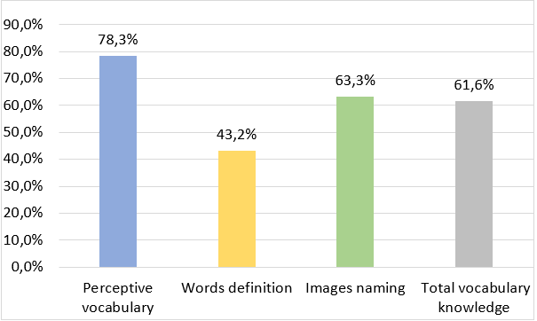

The results of the “Psychosocial Adjustment Test” indicated that the study participants demonstrated, on average, low social (M=37.3, SD=1.37), academic (M=38.5, SD=0.5), and emotional (M=36.7, SD=1.6) competence, while significant behavioral problems were also identified (M=60.8, SD=2.64).

**Table 3. Psychosocial adjustment results**

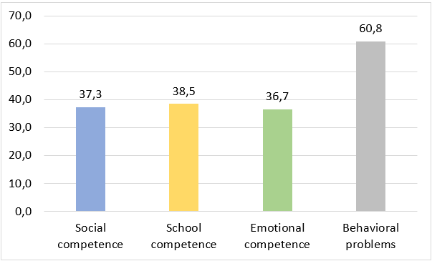

From the SPSS data analysis, it was found that the data did not follow a normal distribution, so the non-parametric Spearman’s correlation coefficient (ρ) was chosen. Regarding the results of the variable correlations, it was found that there was a correlation between all the domains compared, though this was not statistically significant in all cases. Specifically, a very strong positive correlation (ρ=0.818) was found between receptive vocabulary and social competence, which was statistically significant (p-value=0.047).

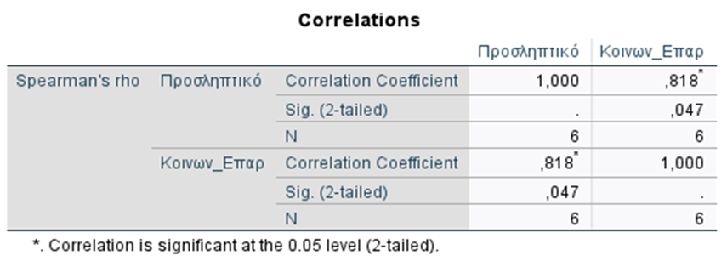**Table 4. Correlations between perceptive vocabulary – social competence**

Additionally, a very strong positive correlation (ρ=0.926) was found between the ability to define words and school competence, which was statistically significant (p-value=0.008).

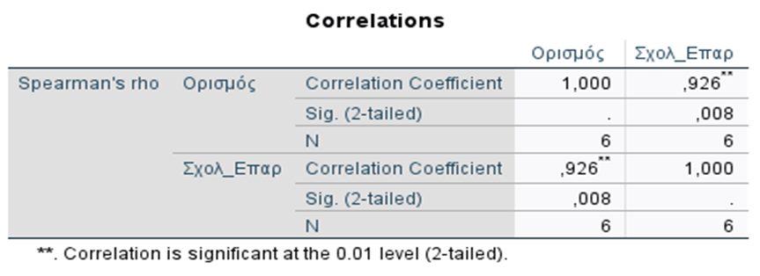**Table 5. Correlation between words definition – school competence**

Moreover, a very strong negative correlation (ρ=-0.812) was found between the ability to define words and the presence of behavioral problems, which was also statistically significant (p-value=0.050).

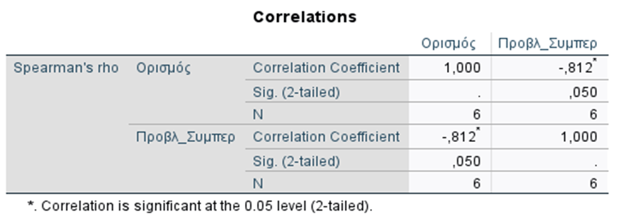**Table 6. Correlation between words definition – behavioral problems**

Therefore, based on the aforementioned results, as the receptive vocabulary of the sample decreases, social competence also decreases, and vice versa. The same relationship is observed between the ability to define words and school competence. Finally, the presence of a strong negative correlation between the ability to define concepts and behavioral problems indicates that as this specific linguistic ability decreases, behavioral problems increase.

**Conclusion**

Through the administration of tools standardized in Greek, reliable and valid data were obtained regarding the vocabulary knowledge of the sample, as well as their levels of psychosocial adaptation. The findings of the present study align with the available literature, as the early school-aged children with ASD who participated in the study showed borderline performance in receptive vocabulary and concept definition tests and low performance in the image naming test, according to the “Logometer.” The existence of deficits in both receptive and expressive vocabulary is also confirmed by the study of Kover et al. (2013), who studied the receptive and expressive vocabulary of children with ASD of a similar age range as the sample of this study.

However, contrary to data supporting that receptive vocabulary falls short compared to expressive vocabulary in cases of children with ASD (Brignell et al., 2019), the sample of this study showed lower performance in expressive vocabulary tests compared to receptive vocabulary.

In terms of psychosocial competence, children with Level 1 ASD who participated in the study showed, on the one hand, low social, school, and emotional competence and, on the other, significant behavioral problems, according to the “Psychosocial Adjustment Test.” These findings are corroborated both by the ASD definition included in the DSM-V and by studies investigating this domain (Nader-Grosbois & Mazzone, 2014).

Regarding the relationship between the two factors under study—vocabulary and psychosocial adjustment—this study provides more detailed data to the existing literature, which notes that the poor vocabulary displayed by a proportion of children with ASD affects their ability to communicate effectively with peers and adults and, consequently, their adjustment to various social situations, as well as their emotional state (Williams et al., 2017).

Specifically, through analysis of the present data, statistically strong correlations were revealed between specific vocabulary domains and psychosocial adjustment. More analytically, the strong correlation found between receptive vocabulary and the sample’s social competence suggests, that the lack of knowledge children with ASD have about the meanings of words, negatively impacts their ability to meet their social obligations and develop healthy social relationships.

Additionally, the reduced ability to define words (expressive vocabulary) shown by the sample was found to be significantly correlated with the school competence of students with ASD (Cascia & Barr, 2017). Consequently, the poor expressive vocabulary of these students negatively affects their ability to organize and execute academic tasks effectively. Also, a strong negative correlation was found between this domain of vocabulary and behavioral problems, indicating that the poorer the expressive vocabulary of children with ASD, the more behavioral problems they exhibit (Afzal, 2019).

Finally, it is worth noting that the findings of this study provide data that could be used for a more comprehensive assessment of early school-aged children with ASD, a period of transitions that each child is asked to manage. A detailed assessment of the needs, difficulties, and strengths of students with ASD increases the chances of creating a personalized and more effective intervention program, improving the child’s daily functioning and quality of life in the long term.

**References**

Afzal, N. (2019). A study on vocabulary-learning problems encountered by BA English majors at the university level of education. *Arab World English Journal (AWEJ) Volume*, *10*. Retrieved November 27, 2024, from <http://dx.doi.org/10.2139/ssrn.3465990>

American Psychiatric Association. (2013). *Diagnostic and statistical manual of mental disorders, 5th Edition (DSM-5).* Washington: American Psychiatric Publishing.

Archodi, A. (2017). Indicative intervention programs with scientific documentation for children with specific language disorder. In A. M. Ralli, & O. Palikara (Eds.), *Developmental language disorder in children and adolescents. Issues of definition, assessment and intervention* (pp. 119 – 140). Athens: Gutenberg.

Arutiunian, V., Lopukhina, A., Minnigulova, A., Shlyakhova, A., Davydova, E., Pereverzeva, D., ... & Dragoy, O. (2021). Expressive and receptive language in Russian primary-school-aged children with autism spectrum disorder. *Research in developmental disabilities*, *117*, 104042. Retrieved November 25, 2024, from <https://doi.org/10.1016/j.ridd.2021.104042>

Brignell, A., May, T., Morgan, A. T., & Williams, K. (2019). Predictors αnd growth in receptive vocabulary from 4 to 8 years in children with and without autism spectrum disorder: A population-based study. *Autism*, *23*(5), 1322–1334. Retrieved November 14, 2024, from <https://doi.org/10.1177/1362361318801617>

Camilleri, B., & Botting, N. (2013). Beyond static assessment of children’s receptive vocabulary: the dynamic assessment of word learning. *International Journal of Language & Communication Disorders*, *48*(5), 565–581. Retrieved October 18, 2024, from <https://doi.org/10.1111/1460-6984.12033>

Cascia, J., & Barr, J. J. (2017). Associations among vocabulary, executive function skills and empathy in individuals with autism spectrum disorder. *Journal of Applied Research in Intellectual Disabilities*, *30*(4), 627-637. Retrieved November 21, 2024, from <https://doi.org/10.1111/jar.12257>

Chatzichristou, C., Polichroni, F., Bezevegis, I., & Milonas, K. (2008). Psychosocial adaptation tool for preschool and school – age children or psychosocial adaptation test. Athens: Greek ministry of education religious affairs and sports.

Doobay, A. F., Foley-Nicpon, M., Ali, S. R., & Assouline, S. G. (2014). Cognitive, adaptive, and psychosocial differences between high ability youth with and without autism spectrum disorder. *Journal of autism and developmental disorders*, *44*, 2026-2040. Retrieved November 14, 2024, from   
<https://doi.org/10.1007/s10803-014-2082-1>

Hojjati, M., & Khalilkhaneh, M. (2014). Evaluate the ability of autistic children to use expressive language and receptive language. *Journal of Pediatric Perspectives, 2,* 267-275. Retrieved November 15, 2024, from <https://jpp.mums.ac.ir/article_3161.html>

Hsiao, M.-N., Tseng, W.-L., Huang, H.-Y., & Gau, S. S.-F. (2013). Effects of autistic traits on social and school adjustment in children and adolescents: The moderating roles of age and gender. *Research in Developmental Disabilities*, *34*(1), 254–265. Retrieved November 15, 2024, from <https://doi.org/10.1016/j.ridd.2012.08.001>

Kover, S. T., McDuffie, A. S., Hagerman, R. J., & Abbeduto, L. (2013). Receptive vocabulary in boys with autism spectrum disorder: Cross-sectional developmental trajectories. *Journal of Autism and Developmental Disorders*, *43*(11), 2696–2709. Retrieved November 15, 2024, from <https://doi.org/10.1007/s10803-013-1823-x>

Kwok, E. Y. L., Brown, H. M., Smyth, R. E., & Oram Cardy, J. (2015). Meta-analysis of receptive and expressive language skills in autism spectrum disorder. *Research in Autism Spectrum Disorders*, *9*, 202–222. Retrieved October 21, 2024, from <https://doi.org/10.1016/j.rasd.2014.10.008>

Martineli, A. K., Pizeta, F. A., & Loureiro, S. R. (2018). Behavioral problems of school children: Impact of social vulnerability, chronic adversity, and maternal depression. *Psychology: Research and Review*, *31*, 11. Retrieved October 16, 2024, from [https://doi.org/10.1186/s41155-018-0089-9](https://doi.org/10.1186/s41155-018-0089-9%20)

Maskor, Z., M., & Baharudin, H. (2016). Receptive vocabulary knowledge or productive vocabulary knowledge in writing skill, which one important? *International Journal of Academic Research in Business and Social Sciences, 6* (11), 261-271. Retrieved November 13, 2024, from  
<http://dx.doi.org/10.6007/IJARBSS/v6-i11/2395>

McDaniel, J., Yoder, P., Woynaroski, T., & Watson, L. R. (2018). Predicting receptive–expressive vocabulary discrepancies in preschool children with autism spectrum disorder. *Journal of Speech, Language, and Hearing Research*, *61*(6), 1426–1439. Retrieved November 15, 2024, from <https://doi.org/10.1044/2018_jslhr-l-17-0101>

Mortazavizadeh, Z., Göllner, L., & Forstmeier, S. (2022). Emotional competence, attachment, and parenting styles in children and parents. *Psychology: Research and Review*, *35*, 6. Retrieved September 13, 2024, from <https://doi.org/10.1186/s41155-022-00208-0>

Mouzaki, A., Ralli, A., Adoniou, F., Diamadi, V., & Papaioannou, S. (2023). *Logometro: a language assessment tool for preschool and early school years children.* Athens: Intelearn.

Nader-Grosbois, N., & Mazzone, S. (2014).Emotion regulation, personality and social adjustment in children with autism spectrum disorders. *Psychology, 5*(15), 1750–1767. Retrieved November 15, 2024, from <https://doi.org/10.4236/psych.2014.515182>

Serrat, O. (2017). Understanding and developing emotional intelligence. In O. Serrat (Ed.), *Knowledge solutions* (pp. 329–339). Retrieved September 20, 2024, from <https://doi.org/10.1007/978-981-10-0983-9_37>

Ukasoanya, G. (2013). Social adaptation of new immigrant students: cultural scripts, roles, and symbolic interactionism. *International Journal for the Advancement of Counselling*, *36*(2), 150–161. Retrieved October 16, 2024, from <https://doi.org/10.1007/s10447-013-9195-7>

Vestad, L., Bru, E., Virtanen, T. E., & Stallard, P. N. (2021). Associations of social and emotional competencies, academic efficacy beliefs, and emotional distress among students in lower secondary school. *Social Psychology of Education*, *24*(2), 413–439. Retrieved September 18, 2024, from <https://doi.org/10.1007/s11218-021-09624-z>

Weiss, J. A., Viecili, M. A., Sloman, L., & Lunsky, Y. (2013). Direct and indirect psychosocial outcomes for children with autism spectrum disorder and their parents following a parent-involved social skills group intervention. *Journal of the Canadian Academy of Child and Adolescent Psychiatry, 22*(4), 303–309. Retrieved November 13, 2024, from <http://hdl.handle.net/10315/28522>

Williams, E. I., Gleeson, K., & Jones, B. E. (2017). How pupils on the autism spectrum make sense of themselves in the context of their experiences in a mainstream school setting: a qualitative metasynthesis. *Autism*, *23*(1), 8–28. Retrieved November 15, 2024, from <https://doi.org/10.1177/1362361317723836>