Educational excursions at home and abroad.
Opinions of teachers of secondary schools of Eastern Attica

Politi Stamatina
High school teacher of philoshophy, PE02
tinapoliti@hotmail.com

Summary
Educational excursions are part of experiential learning and act as an aid to the educational process. Their presence offers multi-level benefits to the educational community. This paper, based on the reference to learning and the benefits of experiential learning, aims at an ad hoc investigation of the advantages of educational excursions, both at home and abroad. The positive results of the excursions are recorded and their added value to the educational community (teachers and students) is presented. At the same time, difficulties and problems in their implementation are identified and, in conclusion, proposals are made for more successful and safer educational excursions. The paper presents the results of the research in relation to benefits-difficulties-suggestions, which was conducted in the school year 2023-2024 in a sample of 95 secondary school teachers (high school) of schools in Eastern Attica.

Key words: learning, experiential learning, extracurricular learning, domestic and international field trip

Introduction
The process of learning is personal and individual in character and involves processes that take place in the life of the individual, both at the biological and the spiritual level (Bigge, 1990). As a human intellectual process, it is an outcome of many evolutionary stages, which are a long-standing field of study of different sciences. Scientists have formulated evolutionarily numerous theories regarding the stages/levels and ways/begins of learning (Flouris, 2005). Recent studies have contributed to the value of collaborative and experiential learning in the educational process and the connection of new knowledge with previous experiences (Foskett & Lumby, 2003).
Experiential learning refers to the learning that results from experience and from the links between school life and students' social life and social reality (Kamarinou, 1998). The value of experiential learning was first perceived by Dewey (Dewey, 1938), who articulated the view that all genuine forms of education are born out of experience. Furthermore, Piaget also pointed out the process of interaction between the person and the environment. The modern school as it is called to transform traditional learning practices and open to society aspires to adopt educational institutions and activities that foster collaborative and experiential teaching process (Al Kadri et al, 2019).
The presence of field trips acts in the upper context and is interconnected with experiential learning, which takes place in and out of the school environment (Waite, 2011). Moreover, educational field trips, both domestic and international, are part of outdoor learning, contain numerous benefits and aim to learn through experience. For all these reasons, their planning and implementation requires methodicalness and overall coordination (Kafetzis, 2010).
The purpose of this research is to examine the contribution of educational excursions, both domestic and international, to the educational reality, to record the views of secondary school teachers regarding their benefits in the overall learning process and to identify difficulties and points towards their more successful and safer realization.

Theoretical framework

Domestic & international study tour

In the present study, the typology of domestic and international educational excursions is the object of study. In table 1 a thorough classification of lyceum excursions is presented.
The category of domestic educational excursions includes either day trips or multi-day trips. Daily or multi-day domestic activities include school walks, educational/teaching visits, excursions, educational trips of pupils, trips in the context of sports activities, participation in conferences/conferences, as well as in the Greek Parliament. Multi-day actions of up to seven (7) days include trips which include a stay of more than one day and which are carried out by pupils in the last year of the last grade of General High Schools (G.L.L.). The participation of 70% of the number of students in the class is a prerequisite for a multi-day trip.
The category of multi-day educational trips abroad includes many categories of trips, which take place in the context of European and international activities. These include educational exchanges following transnational cooperation agreements/ memoranda of understanding, twinning, educational programmes of the General Secretariat for Religious Affairs, European activities/programmes carried out under the Erasmus European programme, programmes of international organisations, participation in international meetings, conferences, workshops, competitions, student science olympiads and other international events, invitations to schools, awards with a trip abroad following participation in competitions and other international events.

Table.1 Lyceum Excursion Classification
Class | Type of Tours | Duration | Usual Destinations | Location
A' Lyceum | One-day or two-day educational excursions, visits to museums, environmental centres, historical sites. In addition, school walks, educational trips for pupils, trips in the context of sports activities, participation in] workshops/conferences, as well as in the Greek Parliament. | Up to 2 days | Museums (e.g. Archaeological Museum of Athens), Delphi, Epidaurus, Centre for Environmental Education in Cleitoria. | Domestic excursions
Β' Lyceum | Multi-day excursions (3-4 days), with an emphasis on history, culture and environmental education. | 3-4 days | Historical cities (e.g. Thessaloniki, Ioannina), mountainous areas (e.g. Karpenisi, Trikala, Corinthia). | Excursions domestic & international
C' Lyceum | Multi-day excursions which take place in the framework of European and international actions (educational exchanges following transnational agreements/cooperation memoranda, twinning, educational programmes, European activities/programmes carried out in the framework of the Erasmus European programme, programmes of international organisations, participation in international meetings, conferences, workshops, competitions, student science olympiads, etc. and other international events, invitations to schools, awards with a trip abroad after participation in a competition procedure approved by the Ministry of Education and Culture, pilot projects of international school networks approved or coordinated by the Ministry of Education and Culture, visits to research centres, educational institutions, universities, cultural centres, visits to European institutions/international organisations after a relevant invitation and acceptance of any request from the international organization for participation in International School Sports Activities and Games). | 5-7 days | Major cities in Greece (e.g. Athens, Patras, Rethymno) or abroad (e.g. Rome, Paris, Vienna, Barcelona). | Excursions  domestic & international

Institutional framework in Greek education

The educational excursions are included in the Government Gazette 456 T.B/13.02.2020 (New Ministerial Decision on Excursions 20883-GD4) entitled: Excursions-Educational visits and travels of students of public and private secondary schools within and outside the country. All categories of visits are included in the Official Journal, article by article. At the same time, the same GSC sets out in detail the conditions for travel, the detailed organisation/processing and the approval procedure, depending on the type of travel, either by the teachers' association of the school unit or by the respective Secondary Education Directorate.

Organisation/targeting
The implementation of field trips requires both direct and indirect links to the curriculum (Bartkus, 2012). Their realization takes place after a specific planning, which includes delimited stages: First: integration into the current institutional framework and their target-oriented organisation based on a horizontal, annual educational planning. Second: implementation in stages on the basis of the current framework, with preparation of study material prior to the visit and on-site evaluation. Ad hoc use of the data for exploitation and highlighting their specific characteristics as ancillary educational elements. Thirdly: a general accountancy dimension by examining their immediate benefits and capturing their long-term added value (Fykaris, 2004̇).
In addition, the creation of successful conditions for their successful and safe conduct plays a catalytic role in their implementation. Meeting the conditions of safety is a prerequisite which is achieved at several stages of implementation: the choice of suitable means of transport, the choice of a destination which is in line with the needs and requirements of the educational unit to which it is directed, the adaptation of the programme to the circumstances and the consideration of the specific characteristics of the pupils. In general, safety is seen as a primary element and guarantee of both immediate success and future repetition (Kibble, 2013).

The importance of educational excursions-Review of existing literature

Value added/Benefits

In the aforementioned Government Gazette 456 T.B/13.02.2020 (New Ministerial Decision on Excursions 20883-GD4), it is noted in the preface that educational excursions are a necessary complement to the education of students, as through their implementation they provide the opportunity to learn about the achievements of man in the long-term course of civilization and to cultivate their sociality. In addition, it is noted that for this purpose, areas of particular educational value (cultural, archaeological, historical, ecological) are selected, while it is considered necessary to provide pupils with prior information and information about the place they are going to visit, in order to ensure the use of previous knowledge and the acquisition of the richest possible experiences.
In this study, the benefits of educational excursions are categorized in two ways: a. the benefits at the individual student level and b. the benefits to the school community.
In relation to the first benefit, during field trips, many benefits are recorded for students: observation is activated, communication and interaction is fostered, positive attitudes towards science and critical thinking through the search for information and harvesting of new experiences and self-activity are cultivated (Broh, 2002). New learning is developed through curiosity, discovery, cooperative team teaching and learning interaction, elements that more successfully consolidate new knowledge (Seow & Pan, 2014). Particularly for secondary education (high schools), their implementation is an ideal opportunity to relieve the already burdened teaching schedule.
All the aforementioned benefits students multiply and contribute catalytically to strengthening their academic performance and preventing undesirable behaviours (Feldman & Matjasko, 2005).
In relation to the second benefit, through the educational excursions, the opening to the local and wider economic and cultural society is made tangible. Through the interconnection with society, their acquaintance with people who are active in it and the resulting experience, pupils become aware that they are part of a wider and universal community, which multiplies the pedagogical and teaching benefits. By activating these processes they are more successfully guided into new learning, develop empathy and gain useful social skills that follow them into later adult life (Lunenburg, 2010).

Implementation problems

The realisation of educational excursions involves at the same time difficulties of implementation, both before and during their realisation. The present study will illustrate the difficulties in connection with their realization in secondary education. The following are identified as negative elements before their implementation: Insufficient planning, lack of organization and unsuccessful preparation are elements that dynamite the implementation. This result is led to by teachers who, due to lack of time because of the workload (especially in high schools), unsuccessful connection with the target setting and study of the curriculum, proceed to poor assessment and inadequate planning (Koulouri-Adtonopoulou & Kassaris, 1988). The catalytic elements of failure during realization also include the lack of investigation of educational needs in relation to the requirements of the school unit's student population. Finally, the negative elements include the lack of security, which can dynamize the outcome and become a fully destabilizing element.
In addition, the literature identifies the short duration of excursions as a serious disadvantage. This disadvantage results in a continuity gap and fragmentation in learning (DeWitt & Storksdieck, 2008).

Suggestions for improvement

At the opposite end of the implementation problems are the suggestions for successful field trips. These include adequate preparation and organisation, investigation of the specific educational needs and requirements of the student population, as well as the creation of safety conditions that guarantee successful realisation. Especially for high schools, early planning at the beginning of the school year, implementation of multi-day (five-day) events in the middle of the school year can guarantee a successful outcome.
Finally, the disadvantage of their short duration and fragmentation of their performance can be prevented by two approaches: according to the first approach, each educational excursion can be organized with a target, which falls organically into the curriculum and at the end there should be utilization and extension of the experiences (Meadows, 2019). According to the second approach, educational excursions can be integrated into a single, horizontal educational programme, which is implemented in phases, includes several visits and is embedded in a corollary. In this case are necessary preparation throughout the year, good planning and broader coordination of the many faculty members involved (Coulangeon, 2018).

Methodology

The quantitative method was chosen for this small-scale survey, as it allows the researcher to collect quantitative data from a large sample of respondents at the same time, while providing the possibility of presenting the results in a grouped way, highlighting trends. A questionnaire was provided for investigation. The survey was conducted during the period 01.11.2023-31.05.2024 on a sample of 95 secondary school teachers (3 high schools-3 high schools) in Eastern Attica, who have organized and participated in more than two educational excursions per year.
The questionnaire used for the present study was tested for reliability and validity after conducting a pilot study on a limited numerical sample. The questions included in it were:

1.Gender
Man
Woman

2. Years of experience in secondary education
0‐5
6‐10
11‐15
16 και
More

3. Education level
High School
Lyceum

4. Please indicate your level of disagreement/agreement with the following statements concerning the benefits of field trips in the learning process, based on the following scale: 1 = Strongly disagree, 2 = Strongly disagree, 3 = Neither disagree nor agree, 4 = Agree, 5 = Strongly agree
 | 1 | 2 | 3 | 4 | 5
Educational trips develop students' empathy and social skills.
During the educational trips, communication and interaction between students is encouraged.
The field trips foster a positive attitude towards science and critical thinking.
Educational trips allow students to be self-directed and gain new experiences.
The educational excursions achieve the opening to the local and wider economic and cultural society.
Educational excursions are an ideal opportunity to relieve the teaching schedule of high schools.
Educational excursions are a catalyst for the improvement of academic student performance.
The implementation of educational trips helps to prevent undesirable behaviour in the student community.

5. Please indicate your level of disagreement/agreement with the following statements concerning the difficulties of implementing educational excursions on the following scale: 1=Completely disagree, 2=Disagree, 3=Neither disagree nor agree, 4=Agree, 5=Completely agree.
 | 1 | 2 | 3 | 4 | 5
Unsuccessful connection with the objectives and purpose of the curriculum leads to the failure of field trips
Poor preparation and lack of organisation undermine the performance of educational excursions
The lack of investigation of the educational needs and requirements of the student population leads to the failure of the educational trips.
The workload in the high schools contributes to the difficulty of implementing educational excursions.
Inadequate security can undermine the realisation of educational excursions.

6. Please indicate your level of disagreement/agreement with the following statements concerning the points for a more successful and safer realisation of educational excursions, on the following scale: 1 = Not at all, 2 = A little, 3 = Quite a lot, 4 = A lot, 5 = Very much.
 | 1 | 2 | 3 | 4 | 5
The link to the specific target and the overall purpose of the curriculum leads to the success of the field trips.
Adequate preparation and organisation contribute to the successful execution of the educational excursions
Exploring the educational needs and requirements of the student population leads to successful field trips.
Saving time in the high schools contributes to the successful implementation of educational trips.
Ensuring safety conditions guarantees the success of the educational excursions.

Most teachers were female (68.9%), with 11-15 years of experience (55.9%) teaching in high school (70.5%).

Results

Most participants agreed that there were identified benefits of field trips in the learning process, particularly in terms of developing empathy, cultivating students' social skills, improving academic performance and preventing undesirable behaviours in the learning community. No difference in the views of respondents was found based on their demographics.
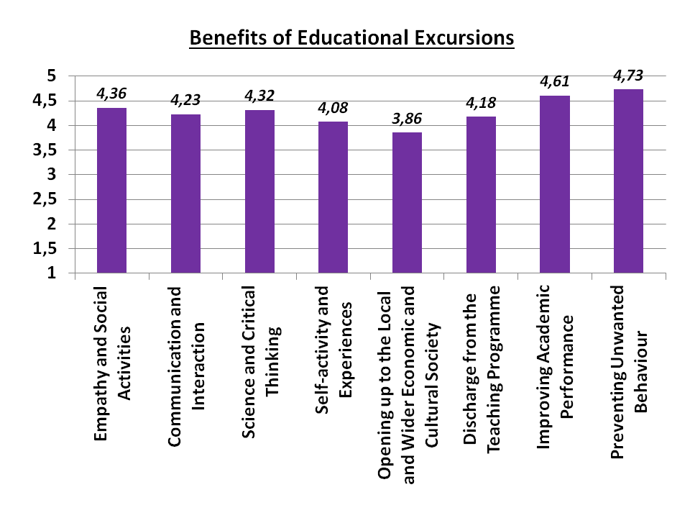

Graph 1. Illustration of the average benefits of field trips on the learning process.

With reference to the difficulties in implementing educational excursions both before and during their realisation, participants agree that poor preparation and lack of organisation, unsuccessful connection with the objectives and purpose of the curriculum and, above all, poor security can be destabilising elements in the implementation of educational excursions. No difference was found in the respondents' opinions based on their demographics.
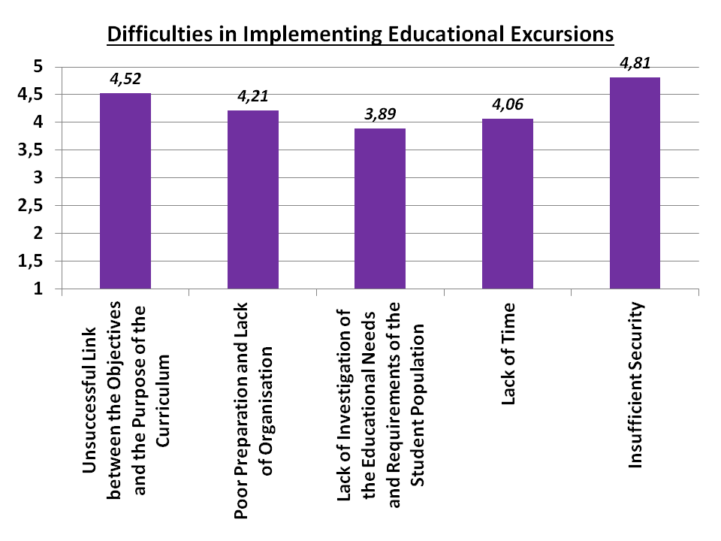

Graph 2. Illustration of the average of the difficulties in implementing educational excursions.

Finally, in the process of finding points for a more successful and safer realization of the educational excursions by the teachers, it was found, in contrast to the above-mentioned, that adequate preparation and organization, the investigation of the specific educational needs and the requirements of the student population, the connection of the specific objectives with the general philosophy of the curriculum and the guarantee of safety conditions guarantee the success of the educational excursions. No difference was found in the opinions of the respondents on the basis of their demographic data.
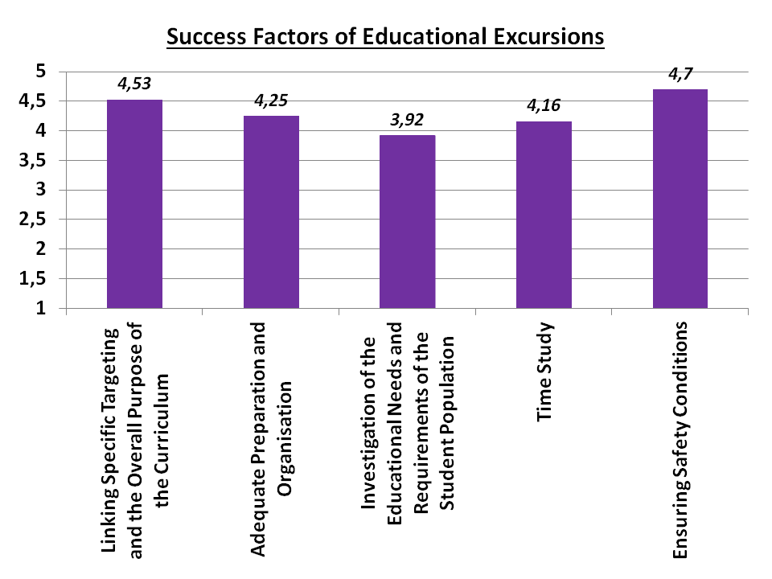

Graph 3. Illustration of the average of the points towards a more successful and safer realization of the educational excursions.

Discussion

The present small-scale survey found that teachers recognize the benefits of field trips in the learning process, a finding that is consistent with the suggestions of other scholars, both in terms of benefits at the individual level and in the school community in general (Broh, 2002; Seow & Pan, 2014; Feldman & Matjasko, 2005; Lunenburg, 2010). Specifically for benefits at the individual level, teachers contribute to the finding for activating observation, fostering communication and interaction, developing positive attitudes towards science, increasing critical thinking through seeking information and harvesting new experiences, and self-activity, points that are consistent with the findings of previous empirical studies. Also, teachers' responses conclude that by going on field trips, new learning develops through curiosity, discovery, cooperative team teaching and learning interaction, elements that more successfully consolidate new knowledge. The above conclusions are consistent with the suggestions of other scholars regarding the enhancement of students' academic achievement and the prevention of undesirable behaviours. (Broh, 2002; Seow & Pan, 2014; Feldman & Matjasko, 2005; Lunenburg, 2010). At the same time, they find that, especially for secondary education (Lyceums), their implementation activates and positively motivates students. Finally, it was found that through the educational excursions, the opening to the local and wider economic and cultural society takes place in practice, students perceive that they are part of a wider and universal event, which multiplies the pedagogical and didactic benefits and the activation of useful social skills, an element that is also found in the literature (Lunenburg, 2010).

Conclusions

This paper has attempted to highlight the benefits of educational visits to the school community, to identify the elements that make their implementation dysfunctional and to detect ways of conducting them effectively. It was perceived that teachers agree on their benefits to the learning process, as they find that they activate students in multiple ways. However, their realisation may not have a successful outcome if basic prerequisites and conditions for their implementation are not met. At this point, the intervention of teachers is crucial, as they are called upon to prevent potential failures through appropriate planning and organisation. It is estimated that the contribution of this study in the field of education lies in the fact that it utilizes the literature references in their ad hoc implementation, their performance in secondary education, traces the data of the Greek reality and attempts to find solutions to possible adversities. The present study can be applied in the educational process and can be utilized especially in the field of suggestions for improvement, as the teachers' responses revealed fruitful ideas for future adoption and usable concerns.

References

Bartkus, K. R., Nemelka, B., Nemelka, M., & Gardner, P. (2012). Clarifying the meaning of extracurricular activity: A literature review of definitions. American Journal of Business Education (AJBE), 5(6), 693-704.
Bigge, M. (1990). Theories of Learning. Athens: Patakis.
Broh, B. A. (2002). Linking extracurricular programming to academic achievement: Who benefits and why? Sociology of Education, 75(1), 69–95. https://doi.org/10.2307/3090254
Coulangeon, P. (2018). The impact of participation in extracurricular activities on school achievement of French middle school students: Human capital and cultural capital revisited. Social Forces, 97(1), 55-90.
DeWitt, J. & Storksdieck, (2008). A short review of school field trips: Key findings from the past and implications for the future. Visitor Studies, 11, 181-197.
Dewey, J. (1938). Experience and education. New York: Macmillan.
Feldman, A.F. & Matjasko J.L., (2005). The Role of School-Based Extracurricular Activities in Adolescent Development: A Comprehensive Review and Future Directions. Review of Educational Research, 75(2), 159-210.
Foskett, N. & Lumby, J., (2003). Leading and Managing Education: International Dimensions. London: Paul Chapman Publishing.
Al Kadri, H. H., Al Kadri, H., Ningrum, T. A., Santoso, Y., & Ratnawati, R. (2019). Planning for Extracurricular Activities. In 5th International Conference on Education and Technology (ICET 2019). Atlantis Press.
Kibble, D. G., (2013). Safety and Disaster Management in Schools and Colleges: a training manual. London: Routledge.
Lunenburg, F.C., (2010). Extracurricular Activities. SCHOOLING, Volume 1, Number 1.
Meadows, A. (2019). The impact of participation in extracurricular activities on elementary school students, Journal of Interdisciplinary Undergraduate Research, 11(1), 23-35.
Seow, P. S., & Pan, G. (2014). A literature review of the impact of extracurricular activities participation on students’ academic performance. Journal of Education for Business, 89(7), 361-366.
Waite, S., (2011). Teaching and learning outside the classroom: Personal values, alternative pedagogies and standards, Education 3–13, 39, 65-82.
Kamarinou, D. (1998). Experiential learning in school.Athens: Grigoris.
Kafetzis, I., (2010). Inventory of Science and Technology Museums in Greece: Inventory of Educational Programs, Materials and Interventions of the Museums, Unpublished Doctoral Dissertation. Patras: EAP.
Koulouri-Adtonopoulou, R., & Kassaris, C. (1988). The museum as a medium of art and education. Athens: Kastaniotis.
Flouris, G. (2005). The architecture of teaching and the process of learning. Athens: Grigoris.
Fykaris, I. (2004). Museum and school: process of organizing a teaching visit. Education Sciences, 1/2004, 109-116.

