Using the Persona Dolls to approach diversity and fight discrimination

Abstract
The Persona Doll method is part of an educational approach to social justice. Persona dolls have personal identities and stories that represent aspects of diversity. It is a method whose main objective is to raise awareness among young children of the issue of injustice in their school and family environment and in the society in which they grow up. In addition, the method is a mean to develop emotional literacy with benefits not only for young children, but also for adults. This paper seeks to highlight this dimension and to present the activities carried out in the context of a cultural programme. The title of the project was “We approach diversity and fight discrimination with Persona Dolls” and it was implemented during the current school year 2024-2025, by 3rd year adult students studying for the nursery assistant degree at the Evening Vocational Lyceum in Northen Greece. The paper seeks to present the impact of the method in improving the personal beliefs and attitudes of preservice early childhood educators’ assistants towards multiculturalism and inclusion.
Keywords: Persona Dolls, inclusion, vulnerable groups, nursery assistants

1.Introduction
In today’s modern multicultural early childhood education and training classrooms, the effective management of all forms of diversity (such as gender, race, ethnicity, religious belief, socio-cultural background, special educational needs and disabilities), the prevention and treatment of discrimination, as well as the promotion of educational and social inclusion, are fundamental priorities of educational practice (Kazela, 2018). UNICEF (2022), denotes that views on injustice and stereotypes begin to develop in young children between the ages of three and four. The Persona Doll method was created to address this very issue in young children in an understandable and pedagogical way for children of this age (UNICEF, 2022). The Persona Dolls that are used in early childhood classrooms are not dolls to play with, but dolls that are directly related to the issues of diversity and are integrated as members of the classroom with their own characteristics and personal stories (Morris, 2023).
The Persona Doll method is mainly used in the context of the educational process with the aim of promoting social justice, anti-racist education, strengthening the acceptance of diversity, the prevention of bullying, as well as for the processing of complex and sensitive issues that arise in the school environment (Kantartzi, 2023).
Persona dolls are routinely involved in the kindergarten or nursery classroom during plenary discussions, telling stories. Issues that arise are sometimes pleasant and joyful, sometimes with concerns and difficulties. With the guidance of the educator, young children are able to interact with the doll and to suggest solutions to the problems they face as well as share moments of joy (Morris, 2023). Through this process, children are encouraged to develop empathy and work through sensitive issues related to prejudice and discrimination in a safe and supportive learning environment under the guidance of the educator at all times (Morris, 2023).
In order to transform the inanimate dolls into persons with emotional and pedagogical impact, educators create for each of these dolls a distinct ‘personality’. This is an imagined but systematically constructed identity, including ethnicity, gender, linguistic identity and family background. Social-emotional learning is enhanced through comparing and contrasting the similarities and differences between dolls and children, while both aspects of difference and shared experiences are naturally highlighted (CASEL, 2020).
2.Theoretical framework
The introduction of Persona Dolls that do not reflect the characteristics of the particular group of children in the classroom can act as a bridge towards fostering intercultural awareness and respect for the ‘other’ (Banks, 2004). Especially in environments characterised by cultural homogeneity and monolingualism, the presence of diversity through Persona Dolls creates opportunities for discussion, deconstruction of stereotypes and gradual cultivation of empathy. According to Vygotsky (1978), learning is rooted in social interactions and play is a key means of developing thinking and identity. Persona dolls become vehicles of narrative, experience and identification, allowing children to approach different life experiences with respect and curiosity, when consciously integrated in a pedagogical way in the classroom.
Children respond naturally to the presence of the Persona doll, often developing a spontaneous bond with it. At the same time, educators also tend to treat her/him as a person with an emotional substance, resulting in a profoundly enriching educational interaction. Siraj-Blatchford (2004) stress that educators explore and challenge the negative values, social stereotypes and prejudices that fuel marginalisation and inequality through creating personal ways of using the doll in a playful and experiential way. The use of Persona Dolls aligns with the principles of anti-racist and inclusive education, which support the need for the education system to be actively involved in promoting social justice (Nieto, 2010; Derman-Sparks & Edwards, 2019). Through storytelling and critical inquiry, Persona Dolls create a safe learning environment that encourage interactive learning and reflection for both children and educators.
Furthermore, through their participation in pedagogical interventions with Persona dolls, educators become aware and understand more deeply their personal assumptions and attitudes that may contain stereotypes or suggest prejudice. At the same time, educators broaden their knowledge and perceptions of the diversity that characterises the contemporary world. Thus, they contribute to improving the equal opportunities practices in their educational programme and to effectively supporting vulnerable groups. As Dimitriadi (2018) supports through this process, they cultivate a non-judgmental attitude which enhances their pedagogical competence and sensitivity.
Moreover, through practicing Persona Dolls, educators are encouraged to avoid imposing personal opinions and ideas on children, choosing to support them in freely expressing their feelings and developing their speech, while strengthening their vocabulary. Finally, they adopt a responsible and prejudice-free attitude when communicating with children, while significantly improving their communication skills, both in terms of creative dialogue with children and in collaboration with other adults (Dimitriadi, 2018).
2.1 Persona Dolls in the Greek settings
The use of Persona Dolls has emerged as a powerful educational tool, particularly in promoting inclusion, empathy, and emotional literacy within the Greek preschool settings. These dolls are given names, backgrounds, and personalities and are used to introduce children to diverse life experiences and social situations. Research by Dimitriadi (2015) and others shows that when educators use Persona Dolls to tell stories of exclusion, bullying, or migration, children respond with emotional engagement and begin to develop empathy, problem-solving skills, and a greater understanding of fairness. For example, refugee and migrant children in Greece have connected deeply with dolls whose stories mirror their own, helping to strengthen both their language skills and cultural identity. In the everyday kindergarten setting, Persona Dolls are also used in free play and dramatic storytelling to address stereotypes and gender norms.
Observational studies have found that children treat dolls as emotionally real characters, enabling deep conversations about emotions, relationships, and values. Dolls can also support differentiated teaching, helping young learners develop cognitive, motor, and social skills through symbolic play. As a result, Persona Dolls have become a key part of inclusive early childhood education practices in Greece, especially in multicultural and refugee-supportive environments (Vitsou & Al‑Jubeh, 2021).
2.2. Our cultural program
The cultural program "We approach diversity and fight discrimination with Persona Dolls", as described in this paper, concerns an educational intervention in the framework of a school activities program, which was implemented in adult female 3rd year students trained to become nursery nurse assistants in Northen Greece. This project was based on the findings of research which underline that the attitude and beliefs of the educators themselves act as an important barrier for the promotion of inclusive education.
Studies, such as Angelides et al. (2007), show that educators marginalise some categories of children in the classroom, either consciously or unconsciously. Their positive or negative attitude is a decisive factor in implementing behavioral education and supporting vulnerable groups (Angelides et al., 2007; Bhatnagar & Das, 2014). Moreover, according to the literature, educators interpret and implement intercultural education policies in their classrooms based on their values and beliefs about pluralism and intercultural education (Chatzisotiriou & Angelidis, 2018). The design of this programme aimed at the benefits of this method for educators (Dimitriadis, 2018), as previously mentioned:
- Training pre-service early educator assistants in intercultural approach and inclusion in order to understand themselves and how their own individual, family and ethnic cultures influence their beliefs, attitudes and values in relation to their practices for the education and training of preschool children,
- Cultivate an appreciation of diversity through experiential experiences that encourage the adoption of alternative perspectives and the ability to interpret their pedagogical and educational practices, taking into account children's perspectives,
- Developing inclusive practices, as well as raising awareness of the socio-political challenges, racism and domestic violence that some children face in early childhood education and training settings.
3. Implementation of the project
The program was implemented in 15 two-hour sessions during the school year 2024-2025. It began in December 2024 and was completed in May 2025. Fifteen adult students of the third class of nursery nurse assistants and the teachers in charge of the specialty participated in the workshop.

3.1 Presentation of the project activities
In this section the activities carried out during the school year 2024-2025 will be presented starting with the placements of the pre-service early educator assistants on the KWLU strategy (Filippatou, 2013, p.61) implemented during this project.
Initially, an open plenary discussion was held in December 2024 on the issue of diversity and discrimination in the school environment and the students' views and autobiographical experiences were analysed in order to determine to what extent the lived experiences could influence their pedagogical practice in the classroom.
Then, the introduction to the topic was carried out by using the strategy "KWLU - Know, Want to know, Learned and Use" (Filippatou, 2013, p.61) in order to explore the students' pre-existing knowledge and interests about Persona Dolls as well as the post-project impressions. Below are indicative examples of some of the students' responses in which we have tried to preserve their confidentiality and anonymity.
3.2. Sample of student responses at the beginning of the project
The responses of the participants presented below show that students were not informed about the Persona Dolls prior to the implementation of the project, that they wanted to know how to enable children deal with issues of discrimination and injustice. At the end of the project all students showed confidence in using the Persona Doll method when they will be given the opportunity in the preschool classroom.
Student 1: Persona dolls I don't know something I wanted to know what purposes it serves, how I can use them, how I will present them to children, how I should create them.
Student 2: I know nothing at all about the specific subject of Persona Dolls. I am very curious to know what they are about, what they are helping and in what way.
Student 3: Initially and before the start of the work I do not know the persona doll and I do not know what purpose this doll serves During the work in the classroom, I would like to know other information about their contribution in the context of a school class as well as the methods and ways of its smooth integration into the school community.
Student 4: I don't know about Persona Dolls I want to know their usefulness, how we use them and when, and what are the benefits to children.
Student 5: I know a little but I have the opportunity through my personal contact to know much better, what is the Role and what is the presence of a Doll that captivates the child's imagination for learning, expression of emotion. I want to know first of all how the Persona Dolls are made, how it works and how they are made by what process with.
From the indicative responses it is clear that the students had little to no prior knowledge about Persona Dolls, that they were interested in learning more information about both their construction and their use in the nursery classroom. This was followed by a collaborative exploration of the topic by searching and studying relevant scientific (print and digital) resources under the guidance of the teachers in charge.
In January 2025, the students watched selected some educational videos of the Persona Doll method being presented in the classroom. Later on and during the months February 2025 to April 2025 the students created two Persona Dolls and carried out a practical application of the method in the classroom. The students formed the personal identity in the dolls, inspired their life stories and their living conditions and the problem they face in the school environment. They also made the dolls with simple materials that they obtained. At the end, they practiced on the use of the Personal Dolls in the classroom.
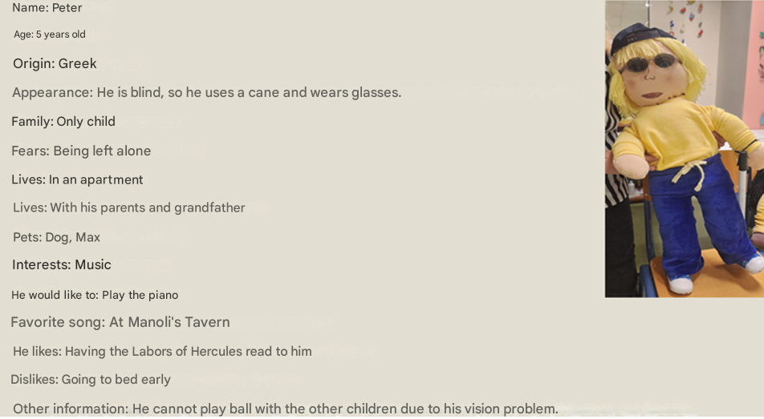
Picture 1: Persona Doll named Peter
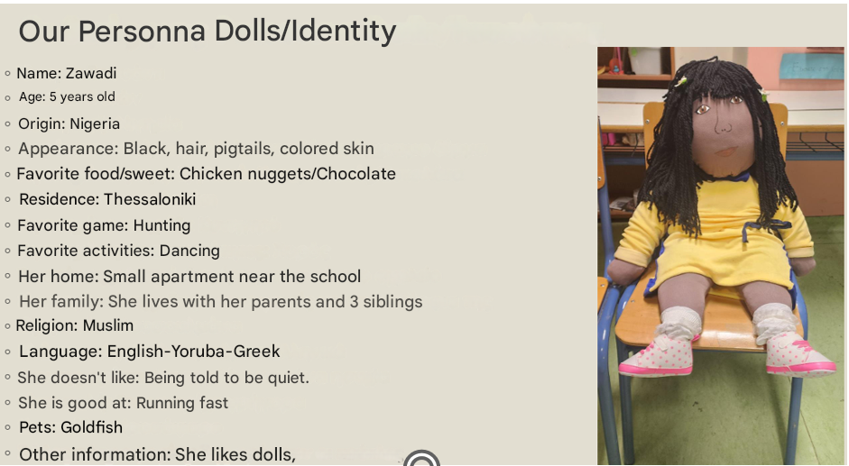
Picture 2: Persona Doll named Zawadi
3.3. Sample of student responses after the completion of the project
At the end of the project, in May 2025, the students filled in the third column of the KWLU chart what they learned and at the end how they can apply the knowledge gained in their professional life and participated in the dissemination of the results of the project in a special event of the school unit.
Student 1: First, I learned the purposes it serves, how I will present it, for what problems, and finally the creation of the cases where we could use them many.
Student 2: The knowledge I gained is very important because it is a very sensitive part of children's mental health. [I also learned] how I can raise awareness among children as an educator towards very subtle issues of diversity. Cultivate their empathy and promote the desired behavior and treatment on such sensitive issues. To accept their fellow man with whatever diversity he possesses and to have harmony in their relationships inside and outside the classroom. As an educator I would apply this particular pedagogical way with persona doll for all the above reasons.
Student 3: After completing the program, I realized the alternative connotation that such a doll can bring to the various difficulties and issues that arise between children. I also saw in practice that its application is not as difficult as I thought and that it can be used by the educator, always observing the rules for its smooth use in the classroom without going beyond the limits, except for specific purposes.
Student 4: I learned all this as much as possible (from how you make them, how you manage them, etc.), it is a very important tool for the teacher to solve some issues that may arise in the classroom or to prevent some behaviors he has observed from developing badly. It is a great way to introduce children to diversity, acceptance, etc. I will use it of course in the future whenever there is a reason.
3.4. Evaluation of the project
The learning experience of the students in the cultural project "Approaching Diversity and Fighting Discrimination with Persona Dolls" proved to be pedagogically fruitful and deeply transformative. The active engagement with the Persona Dolls and their life stories not only served as a tool to familiarize with the concept of diversity, but was also served as a catalyst for the cultivation of critical consciousness and professional empathy. The pre-service early educator assistants were asked to position themselves on ethical and social dilemmas concerning acceptance, inclusion and human rights and to honestly examine their personal attitudes, beliefs and prejudices.
During the course of the project, it was observed that despite the initial emergence of stereotypical perceptions on the part of the participants, the process of storytelling, discussion and reflective exploration led to a gradual shift in these positions. The narrative element played a key role in fostering empathy, as through identifying with the difficulties and experiences of the Persona Dolls, the students were able to see 'through the eyes' of a child experiencing social exclusion (Derman-Sparks & Edwards, 2019).
The success of the intervention is inextricably linked to the creation of a safe learning environment, where students were free to express doubts, work through contradictions and collaborate creatively. Recognition of personal limitations and acknowledgement of their personal assumptions as an integral part of the educational process were key steps towards developing a more sensitive and democratic pedagogical attitude.
4. Limitations of the use of Persona Dolls for early educators
While Persona Dolls have proven to be a valuable tool in early childhood education, particularly in Greek kindergartens, their use also comes with several limitations and challenges that educators must consider.
Firstly, the effectiveness of Persona Dolls heavily depends on the teacher’s training, sensitivity, and confidence in handling complex social issues. If educators are not adequately prepared or feel uncomfortable discussing topics like racism, exclusion, or inequality, they may avoid using the dolls to their full potential or simplify the narratives, thereby reducing their educational impact. In some cases, teachers may inadvertently reinforce stereotypes rather than challenge them, especially if they rely on superficial or clichéd representations of diversity without deeper reflection.
Secondly, the use of Persona Dolls requires a consistent and thoughtful approach. Introducing a doll with a backstory only once or in a disjointed way can confuse children or fail to engage them meaningfully. Sustained storytelling, dialogue, and integration into daily routines are essential—but this demands time, planning, and curriculum flexibility, which are not always available in Greek kindergartens with limited resources or rigid time schedules.
Another limitation is the risk of emotional overload or misunderstanding among young children, especially when dealing with sensitive topics like violence, death, or displacement. Some children may feel overwhelmed or become distressed if the dolls’ stories too closely mirror personal trauma. In such cases, educators must be able to recognize emotional signals and respond with appropriate support, which again requires strong pedagogical training and access to psychological support systems—resources that may be lacking in certain educational settings.
Finally, Persona Dolls might not resonate equally with all children. Cultural, gender, and language differences can affect how children relate to the dolls, particularly if the stories do not reflect their lived experiences or if the dolls appear too distant or artificial. This underlines the need for careful selection and adaptation of dolls and narratives to suit the specific context of each classroom. Educators should consider that Persona Dolls are not toys—they are pedagogical tools. Their power lies in the safe emotional distance they offer, allowing children to project, empathize, and reflect. When used thoughtfully, they can be a transformative part of inclusive and democratic early childhood education in Greece.
5. Suggestions for using Persona Dolls in early childhood education settings
During our involvement with this educational practice the following suggestions for using the Persona Dolls in early childhood education settings emerged.
5.1. Develop Realistic and Relatable Stories
Dimitriadi (2015) emphasizes the importance of crafting authentic doll narratives to stimulate empathy and critical thinking in inclusive early years education. So, educators ought to create a detailed backstory for each doll, including age, name, family, hobbies, and life experiences that reflect the social and cultural realities of the children in your class. Include elements such as migration, disability, or language barriers when appropriate. Stories should be emotionally meaningful but age-appropriate and not overwhelming.
5.2. Integrate Dolls into Daily Routines
Psatha & Mousena (2022) stress the importance of integrating dolls across the curriculum for effective learning and development of social-emotional skills. Educators should use dolls consistently—during circle time, storytelling, conflict resolution, or thematic activities—so that children see them as familiar "classmates." Avoid one-time or isolated appearances; continuity builds trust and engagement.
5.3. Encourage Dialogue, Not Direct Teaching
Al‑Jubeh & Vitsou (2021) show that refugee children engaged more meaningfully when the doll acted as a peer asking for help or advice. Therefore, educators should therefore pose open-ended questions through the doll’s voice (e.g., “I felt left out at the playground today. What would you do?”). Avoid lecturing. Let children respond, share feelings, and propose solutions. This fosters agency, empathy, and critical reflection.
5.4. Reflect the Classroom’s Cultural and Social Diversity
Gonitsioti & Magos (2020) highlight the need to challenge gender and cultural stereotypes in play materials, including dolls. In this line, educators should choose dolls with a variety of ethnicities, skin tones, abilities, and family backgrounds to reflect the real diversity of Greek classrooms, especially in urban or refugee-supportive contexts. Avoid tokenism; ensure the stories go beyond appearance to real-life issues.
5.5. Provide Educator Training and Support
Dimitriadi & Stamoulou (2008) found that many Greek educators lacked the confidence or preparation to address discrimination without proper training. Therefore, before introducing Persona Dolls, educators should receive training in anti-bias education, emotional literacy, and trauma-informed practice. Collaborate with psychologists or social workers where possible, especially when addressing sensitive issues.
5.6. Use Dolls to Address Real Classroom Conflicts
Vitsou (2014) documents how dolls used during free play encouraged spontaneous discussions about fairness, bullying, and emotions. Educators should therefore have in mind that when conflicts or exclusion arise in the group, the doll can later "share" a similar experience, helping children process and reflect on what happened without direct blame.
6. Conclusion
This paper is focused on a project about the use of Persona Dolls in approaching diversity and fighting discrimination. The project took place during the 2024-2025 school years with 3rd year nursery nurse assistant students in Northen Greece. Through a series of classroom activities students were able to explore issues on injustice and diversity. An important finding of the project was that by the end of the educational intervention, all participants had developed the ability to identify the strengths of each Persona doll and suggest meaningful ways to support their unique needs within the school context. This demonstrates not only the cognitive deepening achieved, but also the emotional maturation in relation to the child's place in the school environment.
The students' responses demonstrate the knowledge they gained during their participation in this cultural programme as well as their willingness to apply the knowledge gained during their work in the future. While Persona Dolls offer significant potential for fostering empathy and inclusion, their successful use depends on well-trained educators, consistent implementation, and sensitivity to children's emotional and cultural needs. Without these, the impact of the dolls may be limited or even counterproductive.
In conclusion, in a multicultural and ever-changing social environment, preparing educators with the necessary culture of inclusion and awareness becomes imperative (Nieto, 2010). This project showed that even in groups with a culturally homogeneous profile, it is possible to develop strong reflection and cultivate anti-racist pedagogical discourse.
The use of strategies involving the playful element, narrative and dialogue with meaningful symbols such as Persona Dolls contributed substantially to the empowerment of the participants both as pre-service early educator assistants and as socially conscious citizens. And it reinforced the understanding of interculturality not as an abstract concept, but as a dynamic practice that requires continuous learning, authentic communication and openness to diversity.
References
Al-Jubeh, D., & Vitsou, M. (2021). Empowering refugee children with the use of Persona Doll. International Journal of Progressive Education, 17(2), 210-227. https://doi.org/10.29329/ijpe.2021.332.13
Angelides, P., Vrasidas, C., & Charalambous, C. (2007). Teachers’ Practice as a Marginalization Factor in the Process for Inclusive Education in Cyprus. Journal of the International Association of Special Education, 8(1), 20–30.
Banks, J. A. (2004). Multicultural Education: Issues and Perspectives. John Wiley & Sons.
Bhatnagar, N., & Das, A. (2014). Regular School Teachers’ Concerns and Perceived Barriers to Implement Inclusive Education in New Delhi, India. International Journal of Instruction, 7(2), 89–102.
CASEL (2020). Social and Emotional Learning (SEL) Framework. Collaborative for Academic, Social, and Emotional Learning. https://casel.org/casel-sel-framework-11-2020/
Derman-Sparks, L., & Edwards, J. O. (2019). Anti-Bias Education for Young Children and Ourselves. NAEYC.
Dimitriadi, S. (2015). An introduction to diversity and inclusion in early years education. In S. Dimitriadi, Diversity, Special Needs and Inclusion in Early Years Education. SAGE Publications Ltd..
Dimitriadi, S. (2018). The power of the Persona Doll and its narratives in fostering empathy in children: Issues of diversity, discrimination and bullying. In C. G. Papadimitriou & Ch. P.P. and G. Kostaris (Eds.), Education in the 21st century: Seeking innovation, art, creativity, Proceedings of the 3rd Panhellenic Conference 20-22 April 2018 (pp. 426-439). EKEDISY Museum of School Life and Education & Pedagogical Society of Greece-Hellenic Section of the IBBY-Circle of the Greek Children's Book Moraitis School.
Dimitriadi, S., Stamoulou, A., (2008). Views and attitudes of educators regarding diversity and discrimination in the Nursery School. In D. Hatzidimou, K. Bikos, et al. (Eds.), Greek Pedagogical and Educational Research. Athens: Atrapos Publications, Volume A, 606-617. ISBN 978-960-459-079-7.
Filippatou, D. (2013). The role of assessment in differentiated instruction. In S. Panteliadou & D. Filippatou, (Eds.). Theoretical approaches and educational practices (pp. 60-98). Field
Gonitsioti, Ch. & Magos, K. A Car For Boys, A Doll For Girls? Exploring Kindergarten Teachers' Perceptions of Play-Object in Kindergarten,” Exploring the Child's World, vol. 15, pp. 11-21, 2016, Available online at: https://ejournals.epublishing.ekt.gr/index.php/omep/article/view/22185.
Hadjisotiriou, H., & Angelidis, P. (2018). Europeanization and Intercultural Education. From the Transnational to the School Level. Interaction.
Kantartzi, E. (2023). Persona Dolls: approaching diversity in the Museum of School Life and Education. Culture-Journal of Culture in Tourism, Art & Education, 3(2), 36-45.
Kazela, K. (2018) Persona Dolls. An innovative methodology for approaching diversity, refugee issues, prevention of violence and bullying. ATHINA Educational Network. Series: Modern Pedagogical Approaches.
Morris, C. (2023). Teacher Candidates, Persona Dolls, and Class Libraries. Journal of Language and Literacy Education, 19(2), n2.
Nieto, S. (2010). The Light in Their Eyes: Creating Multicultural Learning Communities. Teachers College Press.
Psatha, F. & Mousena, Ε. (2022). Dolls with meaning: The use of dolls in differentiated teaching and learning 2nd Panhellenic Conference: Educational play and art in education and culture. 29-31 October 2021, EKEDISY Museum of School Life and Education & Pedagogical Society of Greece-Hellenic Section of the IBBY-Circle of the Greek Children's Book Moraitis School.
Vitsou, M. (2014). Puppet conflict management: a case study, Exploring the Child's World,(13), 64-72. doi: 10.12681/icw.17917
Vygotsky, L. S. (1978). Mind in Society: The Development of Higher Psychological.

