**Collaborative Decision-Making in Primary Education: The Symbiosis of AI and School Leadership**

**Raptis Nikolaos**

Assistant Professor, Aegean University, Greece

[nraptis@rhodes.aegean.gr](mailto:nraptis@rhodes.aegean.gr)

**Psyrras Nikolaos**

PhD Candidate, Aegean University, Greece

[psed24012@aegean.gr](mailto:psed24012@aegean.gr)

**Koutsourai Sevasmia Aikaterini**

PhD Candidate, Aegean University, Greece

[koutsourai@sch.gr](mailto:koutsourai@sch.gr)

**Abstract**

The study explores school leaders’ attitudes and perceptions regarding the role of artificial intelligence in decision-making within primary education, focusing on how AI is understood and evaluated across key dimensions. A quantitative survey was conducted among 238 public primary school leaders in the South Aegean region (Cyclades and Dodecanese) using simple random sampling. Data were analyzed through descriptive statistics, Mann-Whitney U test, and reliability analysis. Participants showed positive views on AI in automation, data analysis, and predictive assessment. Gender-based differences appeared in levels of agreement and neutrality. Human judgment remains central in complex decisions. Findings are limited to one regional context; broader and mixed-method research is recommended. The research highlights the need for better AI training and ethical governance in school leadership, providing new evidence on how AI in decision-making is perceived by school leaders in a localized educational context.

**Keywords:** School leadership, Artificial intelligence, Decision-making, Primary education

**Introduction**

School leadership and artificial intelligence (AI) are two areas that are increasingly combining to improve the quality of education and the management of educational institutions. The combination of these two areas can offer significant opportunities and challenges. In particular, artificial intelligence (AI) is one of the most powerful tools that can transform school leadership, management, and other educational organizations. Combining AI with school leadership can lead to improved strategies, more effective management, and a more personalized and targeted educational experience (Anas, 2025).

Artificial intelligence has been actively integrated into the field of education in recent years through the use of various technological applications. These include intelligent tutoring systems, adaptive learning platforms, dynamic assessment models, predictive modelling, predictive analytics, learning analytics, and educational games using virtual and augmented reality (Ramirez & Esparrell, 2024). In addition, new forms of AI-enhanced teaching are constantly being developed to personalize the learning experience and enhance educational effectiveness (Guan et al., 2025).

The application of Artificial Intelligence (AI) in school leadership has highlighted significant developments in school administration, enhancing operational efficiency, reshaping administrative processes, and improving decision-making (Fullan et al., 2024; Karakose & Tülübas, 2024). AI-based solutions offer school leaders high-tech tools to analyze student data, allocate resources more efficiently, and support strategic interventions based on scientific evidence (Khairullah et al., 2025).

Recent developments in big data and analytical learning have become integral components of modern education policies, playing a crucial role in enhancing educational efficiency and informing strategic decision-making (Dai et al., 2024). The application of learning analytics, also known as educational data mining, enables the systematic collection and monitoring of data generated from students' educational activities, allowing for the identification of trends and the taking of corrective or proactive, data-driven actions. This ability to analyze learning progress allows school leaders to monitor students' learning outcomes through AI and provide timely, targeted instructions to teachers, enabling them to tailor instruction to each student’s individual needs (Richardson et al., 2021).

**Collaborative decision-making in School Leadership**

Wang (2021) asserts that the key component of school leadership is decision-making. More precisely, individual leaders' choices and those of the organization's members who are influenced and under the principal's authority are what primarily shape leadership in education. Leaders make decisions based on a variety of factors, including social influence, data and information available at the time of the decision, personal preferences, and core values (Putri et al., 2024). Furthermore, organizational outcomes like learning outcomes, school performance, and staff job satisfaction are influenced by the behavioural patterns of school leaders, which are conceptualized as leadership styles.

For many reasons, including time, expertise, and the inherent limitations of educational policies, school principals are not always in a position to make all of the decisions in the organization by themselves. In that case, school leaders can empower other people in the organization and make decisions collaboratively to create decision-making to a higher order of thinking (Hao et al., 2024). That is, recognizing the responsibility to delegate authority for participatory decision making can be in direct contradiction to one's fundamental psychological needs for independence, control, and power (Lammers et al., 2016). To empower members of an organization to make high-quality decisions, leaders must identify the limits of their own need for independence, control, and power (Song et al., 2025). Furthermore, individual decision-making and quality decision-making are inextricably linked (Kozioł-Nadolna & Beyer, 2021). Once one is aware of the deliberative nature of decision-making in school leadership, their thinking can progress by considering how AI connects with school leaders' decision-making (Pawar & Dhumal, 2024).

**AI and decision-making**

One of the key areas where AI can have a positive impact on the school context is data analysis for decision-making. According to Al-Bayed et al. (2024), AI allows school leaders to quickly and accurately process large data sets, facilitating the understanding of student needs and the adaptation of educational programs in real time. This leads to more targeted and effective strategies for managing and developing the school environment. But how can AI actively contribute to a school principal's decision-making?

Through its efficiency in collecting, processing, and analyzing data and providing real-time results, AI can assist school leaders in their decision-making process. Large amounts of data (e.g., test scores, students’ demographics, grades, and teachers’ performance evaluation feedback) are collected each year by educational institutions at various administrative levels, including national, regional, and local authorities (Wang, 2021). School leaders are often faced with similar complex situations that require them to process large amounts of information and consume large amounts of cognitive capacity (Michael et al., 2024). However, making large numbers of decisions and recalling detailed information requires the consumption of increased human cognitive resources, turning decision-making into a mentally process for school leaders. In such cases, limited human cognitive capacity can be enhanced by artificial intelligence with superior quantitative, computational, and analytical capabilities.

Also, school principals can use AI to reduce uncertainty to some extent (Osegbue et al., 2025). Uncertainty cannot be eliminated at the time of decision making. When uncertainty is too great, such as when an organization is facing an unprecedented crisis, making decisions based on data and evidence can be an inefficient process for school leaders.

Furthermore, AI is not limited to educational decision-making processes and has the potential to automate many of the administrative processes related to school management (Aldighrir, 2024). For example, automating resource allocation and human resource management can reduce the workload of school leaders, allowing them to focus on the strategic development of their schools.

Many decisions in education today are not made technologically or mechanically, but are often related to moral values and require human judgment, the responsibility of which lies with individual school leaders (Dai et al., 2024; Wang, 2021). The symbiosis and coexistence of humans and AI in decision-making can be enhanced in two ways. First, AI can process and analyze large amounts of data and act as an augmented brain to make decisions based on data and evidence (Arar et al., 2024). Second, the advantages of AI can free up time for people to focus more on making ethical, values-based decisions (Arar et al., 2024).

The use of machine learning in decision-making at the management level is not a feature exclusive to educational institutions. Other institutions have also employed it to support their leaders. Jarrahi (2018), Wang (2021), and Shrestha et al. (2019) studied the relational modes of human and AI in decision-making contexts. Jarrahi (2018) found that AI systems are more effective at complex problems in analytical decision-making cases, while humans should direct intuitive decision-making cases that involve uncertain and ambiguous circumstances. Wang (2021) states that AI systems are better to use when making data based or evidence-based decisions, while humans should be used for value-based decision-making. Shrestha et al. (2019) propose that AI systems can work without human participation in decision-making contexts where there are clear outcomes.

The goal of these AI-human collaboration models is to examine how AI could enhance human performance with extensive computing power for data recognition while ensuring that humans retain the ultimate authority in decision-making. Machine learning can draw on large datasets and effectively define complex patterns, giving AI systems the ability to analyze data without limits (Wang, 2021). Even cognitive analysis is reshaping frameworks for cognition and behaviour when considering the administrative nature of their contribution (Gulson et al., 2022). In order to understand what these leaders appear to be doing when collaborating or coexisting with them while making decisions, we need to look closely at the contexts and ways that machine learning may be enabling human leaders. Perhaps clarifying the specific roles and responsibilities of each AI leader and human leader, through the decision process, can demonstrate how the two might complement each other.

Although there are a number of studies examining different modes of AI-human collaboration in decision-making, the distinctions between the roles and remedy of AI and human leaders in the decision-making process have not been sufficiently researched and explained, having regard to the school environment and educational leadership. This paper seeks to address this gap by developing a synergistic collaborative framework between AI and school leaders to illustrate how they can coexist within the decision-making process of educational administration in the school system by clarifying their different roles and responsibilities.

**Research method and approach**

This study adopted a **quantitative research approach** to systematically investigate school leaders’ perceptions of the role of artificial intelligence (AI) in decision-making within primary education (elementary schools and kindergartens). A quantitative approach was deemed appropriate for this research, as it enables the collection of measurable data from a large sample, thereby facilitating the identification of patterns, trends, and potential correlations (Cohen et al., 2013; Creswell & Creswell, 2017). Through the use of structured data collection instruments and statistical analysis, the study aimed to ensure objectivity and the reproducibility of results.

The use of a structured questionnaire provided consistency in the responses and allowed for efficient analysis of key variables related to leadership, experience, and attitudes towards the integration of AI in the educational context.

*Research tool and reliability analysis*

To assess its usefulness and validity, the created research instrument was modified and tested on a small group of school principals. The final version of the online questionnaire was reformulated and optimized using the input gathered during this pilot phase. The research questions, which were developed and recorded in the study's introduction, were intended to be adequately addressed by the research instrument. To systematically examine the important aspects of the phenomenon being studied, the research tool comprised 30 questions in total, divided into three sub-themes (see Table 2). In order to quantitatively evaluate the participants' degree of agreement, their opinions were recorded using a 5-point Likert-type scale, where 1 represented total disagreement and 5 represented total agreement.

**Table 2. Sample questions included in the online questionnaire**

|  |  |  |
| --- | --- | --- |
| Demographic data | Attitudes on AI abilities in decision-making | Decision-making |
| Gender, Age, Education, Years of Service, Years in Management Positions | AI facilitates rapid decision-making by automating data processes.  AI enhances decision-making through its advanced big data processing capabilities.  The ability of AI to apply predictive risk analysis aids in making significant decisions. | When I make a decision, I rely on my instinct.  I postpone decision-making whenever possible.  When I make important decisions, I usually need the help of others.  I often procrastinate when I have to make important decisions.  When I have to make an important decision, I need someone else to guide me. |

Regarding the reliability of the research tool, that is, the accuracy of its measurement (Gray, 2018), Table 3 shows that the Cronbach's Alpha reliability coefficient exceeded 70%, which meets the necessary criteria as it is greater than 0.7.

**Table 3. Reliability Analysis**

| Sections of the Questionnaire | Cronbach’s Alpha Coefficient | Number of Variables |
| --- | --- | --- |
| Attitudes on AI abilities in decision-making | 0.858 | 8 |
| Decision-making | 0.773 | 17 |

*Data analysis*

The collected data were analyzed using descriptive statistics to give an overview of the sample and summarize participants’ views on the role of artificial intelligence (AI) in decision-making in primary education (elementary schools and kindergartens). Frequencies, percentages, means, and standard deviations were used to show the demographic profile of the participants and their attitudes toward using AI in school leadership.

These results helped support further analysis to explore possible links between school leaders’ characteristics and their views on AI. In addition, the **Mann-Whitney U test** was used to compare responses between male and female participants, checking for any significant gender-based differences. This approach helped provide a clearer picture of how school leaders in the region understand and evaluate the use of AI in education. All statistical analyses were conducted using SPSS (Version 25.0), ensuring rigor and reproducibility in data handling.

*Sample and methods*

To capture diverse perspectives, **simple random sampling** was employed. The research sample consisted of school leaders from public primary units (elementary schools and kindergartens) in the South Aegean region, including both the Cyclades and Dodecanese islands for the 2024-2025 academic year. A complete list of schools in the region was used to randomly select participants, ensuring that each school had an equal chance of being included. This **probability-based sampling method**enhances the representativeness of the sample and strengthens the generalizability of the findings (Babbie et al., 2022; Bryman, 2017).

An email invitation was sent to 445 primary school units across the South Aegean region, including also small-sized multi-grade primary schools, institutions for special education, and the final sample comprised 238 school leaders, which falls within the benchmarked range that was set by this study. Simple random sampling provided a systematic and unbiased method for capturing context-specific data from school leaders in the South Aegean region (Cyclades and Dodecanese), supporting future comparative analyses with findings from urban educational settings. Data collection took place from early October 2024 to mid-January 2025, and the participants were made aware of their rights, including that their involvement was entirely optional and that their answers would be kept confidential.

The response rate was about 53.5%, with 238 out of 445 school leaders taking part. This means more than half of those invited answered, which is good for this type of study. The estimated margin of error is around ±4.5% at a 95% confidence level. This means the results from the sample are likely close to reflecting the views of school leaders in the South Aegean region (Cyclades and Dodecanese).

To further clarify the sample characteristics, the demographic data for the respondents are illustrated in Table 1, presenting information such as school principals’ gender, age, years of service, education, and years in management positions.

**Table 1. Demographic characteristics**

|  |  |  |  |
| --- | --- | --- | --- |
|  | n | % |  |
| **Gender** |  |  |  |
| Male | 68 | 28.6 |  |
| Female | 170 | 71.4 |  |
| **Age** |  |  |  |
| Under 29 | 4 | 1.7 |  |
| 30-39 | 47 | 19.8 |  |
| 40-49 | 61 | 25.6 |  |
| 50-59 | 96 | 40.3 |  |
| Over 60 | 30 | 12.6 |  |
| **Years of service** |  |  |  |
| 0-10 | 21 | 8.8 |  |
| 11-20 | 77 | 32.4 |  |
| 21-30 | 86 | 36.1 |  |
| Over 30 | 54 | 22.7 |  |
| **Education** |  |  |  |
| Pedagogy studies | 58 | 24.4 |  |
| Other bachelor’s degrees | 16 | 6.7 |  |
| Master | 156 | 65.5 |  |
| PhD | 8 | 3.4 |  |
| **Years in management positions** |  |  |  |
| 0-10 | 187 | 78.6 |  |
| 11-20 | 37 | 15.5 |  |
| Over 20 | 14 | 5.9 |  |

**Findings**

The Likert-type reactions ranged from 1 (Strongly Disagree) to 5 (Strongly Agree), allowing us to identify the typical response for each statement (Table 3). The analysis of school leaders’ reactions regarding the three key decision-making capabilities of Artificial Intelligence (AI) in the context of primary education was conducted using the **median** as the central tendency measure (Table 4).

**Table 3. School leaders’ perceptions of AI's ability in decision-making**

| AI Ability | Disagree Absolutely (%) | Disagree (%) | Neutral (%) | Agree (%) | Agree Absolutely (%) |
| --- | --- | --- | --- | --- | --- |
| AI facilitates rapid decision-making by automating data processes. | 11 (4.6%) | 25 (10.3%) | 65 (27.5%) | 110 (46.2%) | 27 (11.4%) |
| AI enhances decision-making through its advanced big data processing capabilities. | 5 (1.9%) | 20 (8.4%) | 52 (21.8%) | 134 (56.5%) | 27 (11.4%) |
| The ability of AI to apply predictive risk analysis aids in making significant decisions. | 5 (2.3%) | 27 (11.5%) | 74 (30.9%) | 116 (48.9%) | 16 (6.4%) |

**Table 4. Key decision-making capabilities of AI**

| AI Ability | M | Mdn | SD | Min | Max |
| --- | --- | --- | --- | --- | --- |
| AI facilitates rapid decision-making by automating data processes | 3.50 | 4.00 | 0.99 | 1 | 5 |
| AI enhances decision-making through advanced big data processing | 3.57 | 4.00 | 0.92 | 1 | 5 |
| AI aids in making significant decisions through predictive risk analysis | 3.46 | 4.00 | 0.96 | 1 | 5 |

The data presented in the tables highlight school leaders’ perceptions regarding the three core capacities of Artificial Intelligence (AI) in supporting decision-making: **data analysis, automation**, and **predictive risk assessment.** Each of these dimensions reveals varying degrees of acceptance, confidence, and familiarity among leaders in the primary education context.

*AI and big data analysis in decision-making*

The first statement recorded a mean of 3.50, a median of 4.00, and a standard deviation of 0.99, indicating a positive perception among school leaders. The majority of participants (57.6%) responded positively (agree or strongly agree), while only 14.9% expressed disagreement. A considerable share of respondents (27.5%) remained neutral, suggesting that while data analysis is recognized as a strength of AI, there may still be knowledge gaps or implementation barriers that prevent widespread confidence in this area.

The Mann-Whitney U test showed that it was statistically significant only for the gender variable. More specifically, the test between the question "AI facilitates rapid decision-making by automating data processes" and the gender variable revealed that there is a statistically significant dependence between the answers to the question and the gender of the school leaders. Specifically, male principals showed much lower than expected frequencies in the response "neither agree nor disagree", while their female colleagues showed much higher than expected frequencies. The opposite pattern was observed for the response "agree" or "strongly agree". It suggests that male principals tended to avoid neutral answers, preferring to take a clear position. Whereas female school leaders were more inclined to choose a more reserved or neutral stance, perhaps showing more inhibition or reflection on this issue.

*AI and rapid decision-making through automation*

The second statement yielded the highest mean (3.57) and lowest standard deviation (0.92) among the three statements, with a median of 4.00. A total of 67.9% of respondents agreed or strongly agreed, the highest agreement rate in the set. Fewer participants were neutral (21.8%) or negative (10.3%). These findings suggest that automation is the most understood and widely accepted function of AI among school leaders, likely due to its visible role in administrative and routine operations. The Mann-Whitney U test between the question "AI enhances decision-making through advanced big data processing" and the demographic variables showed that it was not statistically significant for all of them.

*AI and predictive risk assessment in decision-making*

The third statement received the **lowest mean score (3.46)** but retained a **median of 4.00** and a **standard deviation of 0.96,** indicating some divergence in views. While **55.3%** of school leaders agreed or strongly agreed, **30.9%** chose a neutral response, and **13.8%** disagreed. This implies that predictive modeling is a **less tangible or less familiar concept** for many school leaders in primary education. It may also reflect a **lack of practical experience or exposure** to how predictive analytics can inform educational policy, resource allocation, or student support.

The Mann-Whitney U test showed that it was statistically significant only for the gender variable. More specifically, the Mann-Whitney U test between the question "AI aids in making significant decisions through predictive risk analysis" and the gender variable showed that male school leaders chose the response "neither agree nor disagree" significantly less often than expected, while their female colleagues chose this neutral response significantly more often. In contrast, in the "agree" or "strongly agree" response category, male managers showed significantly higher than expected frequencies, while female managers showed lower frequencies.

These findings suggest a gender-related difference in how leaders perceive the role of AI in decision-making. Male school leaders appear to be more resolute in expressing their agreement with the proposal, while women school leaders tend to adopt a more reserved or neutral stance. This gender variation may reflect differences in familiarity, confidence, or attitudes towards new technologies such as AI, or may be influenced by social or organisational factors that shape behavioural responses.

The analysis reveals a moderate-to-positive attitude toward AI's potential in educational decision-making overall, with the greatest confidence in automation and a relatively low level of familiarity with predictive functions. Neutral responses, particularly in more complex AI functions, indicate a need for additional training, awareness, and implementation strategies to better prepare school leaders for an AI-enhanced decision-making landscape. Even though the median score of 4.00 across all items suggests a general tendency toward agreement, this finding highlights the importance of further refinement.

The following graphs illustrate school leaders’ perspectives, highlighting key aspects of the relationship between Artificial Intelligence (AI) and human involvement in decision-making.

• In response to the question, "To what extent do you believe AI can replace human judgment in the decision-making process?"*,* the largest group of school leaders, 87 respondents (36.6%), answered "Enough". A similar number, 83 individuals (34.7%), responded "A little". Meanwhile, 32 school leaders (13.4%) stated "None", 27 (11.5%) answered "Much", and finally, 9 participants (3.8%) indicated "Very much".

**Graph 1. To what extent do you believe AI can replace human judgment in the decision-making process?**

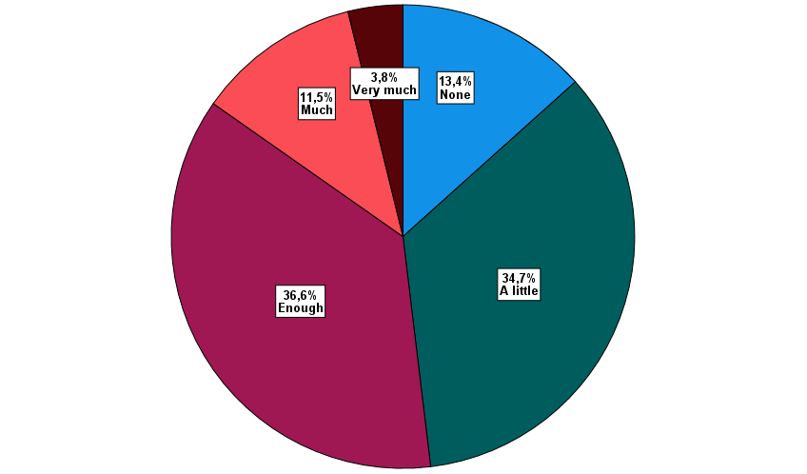

**•** Regarding the question**,** "Do you believe AI algorithms can be more objective than human judgment when assessing situations?", **141 respondents (59.2%) answered "No",** indicating that the majority of school leaders are sceptical about the objectivity of AI over human judgment. Meanwhile, 97 school leaders (40.8%) stated **"Yes",** suggesting that a significant minority acknowledge AI’s potential to bring a level of impartiality to assessments that human decision-makers might struggle to maintain due to personal biases or emotional influence.

**Graph 2. Do you believe AI algorithms can be more objective than human judgment when assessing situations?**

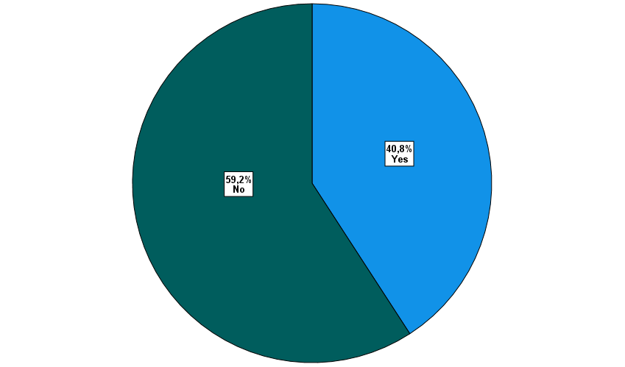

**•** In response to the question, "To what extent should humans retain the final decision in processes fully supported by AI?"*,* the overwhelming majority of school principals in the sample, **152 participants (64.1%)** answered "**fully**"**.** An additional **81 principals (34.0%)** chose "**partially**"**,** while only **5 respondents (1.9%)** stated that humans **should not retain** any final decision-making authority.

**Graph 3. To what extent should humans retain the final decision in processes fully supported by AI?**

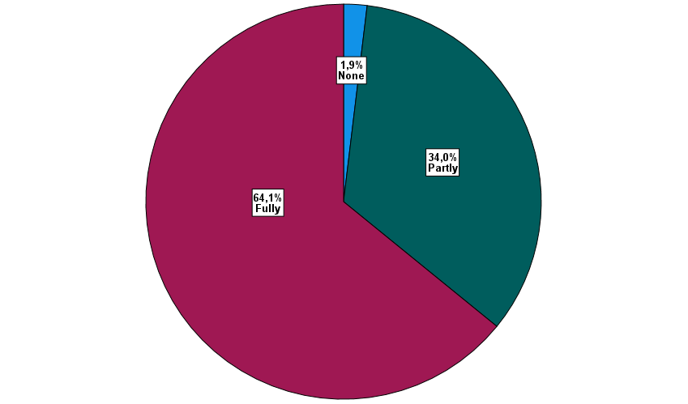

**Discussion**

The use of Artificial Intelligence (AI) to enhance decision-making in primary education is not about entirely replacing machine-based judgment for human-based judgment, but is an emerging and symbiotic relationship that relies on the combined strengths of both (Dai et al., 2024; Jarrahi, 2018; Shrestha et al., 2019; Wang, 2021). The implications of this study demonstrate that school leaders are trying to balance the prioritization of human oversight but still value the potential that AI can serve as a helpful and supporting tool in some areas, such as data analysis, automation, and predictive modeling (Himeur et al., 2023; Zong et al., 2024).

However, a significant number of school leaders maintained their neutrality, even though AI's capacity to handle and analyze large data was also well-received. This implies either a lack of experience with complex data interpretation or a lack of confidence in the use of data-driven outputs for strategic or pedagogical objectives. This finding is in line with Wang et al. (2023), who found that a lack of conceptual clarity and data literacy leaves many school leaders feeling unprepared to interpret AI-generated insights in a meaningful way.

Predictive risk assessment was the topic of the most cautious opinions. The high percentage of neutral and negative answers raises questions about probabilistic reasoning and the ethical implications of AI-based forecasting. People who are used to making decisions based on human judgment and context might find predictive analytics hard to trust because it often relies on unclear algorithms and data that lacks context (Beckley, 2025; Zekos & Zekos, 2021).

Additionally, this study indicates that school leaders do not see AI as a replacement for human decision-makers, but as a partner in a symbiotic process of deliberation. This is consistent with the symbiotic decision-making theory, which supports that humans are still in charge of interpretation, moral reasoning, and final judgment while AI handles computational support (Almeida & Senapati, 2024; Wang, 2021). This model is especially useful in education since decision-making frequently involves interpersonal, affective, and subjective factors that are impossible for modern AI systems to replicate (Dai et al., 2024). AI can find patterns and problems in data well, but it doesn't have the moral judgment, empathy, or understanding of context needed to make the best decisions for principals and schools (Holmes & Tuomi, 2022; Pham & Sampson, 2022).

Recent studies support the notion that human-centered, rather than fully autonomous, AI deployment in education is the most effective approach (Kayyali, 2025; Mena-Guacas et al., 2023; Ramadevi et al., 2023). In this approach, AI helps to uncover insights, identify possible problems, and produce forecasts, but humans decide how to react based on their values, empathy, and work experience (Bankins et al., 2022; Zimmerman et al., 2024).

This framework is reflected in the study's results, especially the strong support for human-led decision-making and the low support for fully autonomous AI. School leaders are open to using AI for analysis and routine tasks, but they keep the more morally complex decisions for humans to make. Indeed, many decisions in education today are not made technologically or mechanically, but are often related to ethical values and require human judgment, the responsibility of which lies with the respective school leaders.

*Implications*

This study contributes to the theoretical body of knowledge on the relationship between artificial intelligence and school leadership, particularly in the context of decision-making. According to the findings, school leaders face artificial intelligence (AI) as a useful tool for making decisions, but not as a replacement for human judgment. Although AI's ability to automate data processes and analyze complex information is widely supported, there is still doubt about its capacity to take the place of human judgment in morally or contextually complex decision-making. This suggests a definite preference for a symbiotic model of decision-making, in which humans maintain control over interpretation, values-based reasoning, and final judgment while AI handles analytical tasks.

School leaders urgently need to receive focused professional development in data literacy and AI competency to support this model. It is imperative that educational developers and policymakers make sure AI systems are transparent, human-centered, and built to support expert knowledge. Governance frameworks should define ethical limits, protect human accountability, and make sure AI tools advance educational values and equity rather than undermine them.

*Limitations and future research*

Despite efforts to ensure a representative sample through simple random sampling, several limitations should be acknowledged. First, the response rate of 53.5%, while acceptable, means that nearly half of the invited school leaders did not participate, which could introduce some non-response bias if the views of non-respondents differ from those who responded. Second, the study focuses exclusively on school leaders from public primary units in the South Aegean region, which may limit the generalizability of the findings to other educational levels, private schools, urban areas or regions with different socio-cultural contexts. Third, as the data collection relied on self-reported responses via email surveys, there is a risk of social desirability bias or inaccurate reporting. Finally, the design captures perspectives at one point in time (2024-2025 academic year), which may not reflect changes in attitudes or conditions over time.

A more representative and varied sample of school leaders from various institutional, cultural, and geographic contexts, including urban and global ones, should be included in future studies. A deeper comprehension of the distinctions underlying school leaders' attitudes toward AI may be possible through mixed-methods research that combines qualitative interviews and quantitative surveys. The existing body of evidence would also be greatly enhanced by studies on the real-world applications of AI tools in decision-making processes and their effects on academic results.

**References**

Al-Bayed, M. H., Hilles, M., Haddad, I., Al-Masawabe, M. M., Alhabbash, M. I., Abu-Nasser, B. S., & Abu-Naser, S. S. (2024). AI in Leadership: Transforming Decision-Making and Strategic Vision. International Journal of Academic Pedagogical Research, 8(9), 1–7.

Aldighrir, W. M. (2024). Impact of AI ethics on school administrators’ decision-making: the role of sustainable leadership behaviors and diversity management skills. *Current Psychology*, 43(41), 32451–32469. <https://doi.org/10.1007/s12144-024-06862-0>

Almeida, F., & Senapati, B. (2024, March). Striving for symbiosis: Human–machine relations in the AI era. In *2024 IEEE Integrated STEM Education Conference (ISEC)* (pp. 1–4). IEEE. <https://doi.org/10.1109/ISEC61299.2024.10664823>

Anas, I. (2025). The impact of artificial intelligence on educational leadership: Challenges and opportunities in school management. *Journal of Islamic Education Management*, *2*(01).

Arar, K., Tlili, A., & Salha, S. (2024). Human-machine symbiosis in educational leadership in the era of artificial intelligence (AI): Where are we heading? *Educational Management Administration & Leadership*. <https://doi.org/10.1177/17411432241292295>

Babbie, E., Wagner-Huang, W. E., & Zaino, J. (2022). *Adventures in social research: Data analysis using IBM SPSS statistics*. Sage Publications.

Bankins, S., Formosa, P., Griep, Y., & Richards, D. (2022). AI decision making with dignity? Contrasting workers’ justice perceptions of human and AI decision making in a human resource management context. *Information Systems Frontiers, 24*(3), 857–875. <https://doi.org/10.1007/s10796-021-10223-8>

Beckley, J. (2025). Advanced risk assessment techniques: Merging data-driven analytics with expert insights to navigate uncertain decision-making processes. International Journal of Research Publication and Reviews, 6(3), 1454–1471. <https://doi.org/10.55248/gengpi.6.0325.1148>

Bryman, A. (2017). Quantitative and qualitative research: further reflections on their integration. In *Mixing methods: Qualitative and quantitative research* (pp. 57-78). Routledge.

Cohen, J., Cohen, P., West, S. G., & Aiken, L. S. (2013). *Applied multiple regression/correlation analysis for the behavioral sciences*. Routledge.

Creswell, J. W., & Creswell, J. D. (2017). *Research design: Qualitative, quantitative, and mixed methods approaches*. Sage Publications.

Dai, R., Thomas, M. K. E., & Rawolle, S. (2024). The roles of AI and educational leaders in AI-assisted administrative decision-making: A proposed framework for symbiotic collaboration. The Australian Educational Researcher, 52, 1471–1487. <https://doi.org/10.1007/s13384-024-00771-8>

Fullan, M., Azorín, C., Harris, A., & Jones, M. (2024). Artificial intelligence and school leadership: challenges, opportunities and implications. *School Leadership & Management*, *44*(4), 339-346. <https://doi.org/10.1080/13632434.2023.2246856>

Gil, Y., Garijo, D., Khider, D., Knoblock, C. A., Ratnakar, V., Osorio, M., Muslea, I., Minton, S., Oh, J., Radensky, M., & Shu, L. (2021). Artificial intelligence for modeling complex systems: Taming the complexity of expert models to improve decision making. ACM Transactions on Interactive Intelligent Systems, 11(2), 1–49. <https://doi.org/10.1145/3453172>

Gray, J. R. (2018). Introduction to qualitative research. *Understanding Nursing Research E-Book: Building an Evidence-Based Practice*, *59*.

Guan, L., Zhang, Y., & Gu, M. M. (2025). Pre-service teachers' preparedness for AI-integrated education: An investigation from perceptions, capabilities, and teachers’ identity changes. *Computers and Education: Artificial Intelligence*, *8*, 100341. <https://doi.org/10.1016/j.caeai.2024.100341>

Gulson, K. N., Sellar, S., & Webb, P. T. (2022). *Algorithms of education: How datafication and artificial intelligence shape policy*. University of Minnesota Press. <https://doi.org/10.5749/9781452968797>

Hao, X., Demir, E., & Eyers, D. (2024). Exploring collaborative decision-making: A quasi-experimental study of human and generative AI interaction. Technology in Society, 78, Article 102662. <https://doi.org/10.1016/j.techsoc.2024.102662>

Himeur, Y., Elnour, M., Fadli, F., Meskin, N., Petri, I., Rezgui, Y., & Amira, A. (2023). AI-big data analytics for building automation and management systems: A survey, actual challenges and future perspectives. Artificial Intelligence Review, 56(6), 4929–5021.

Jarrahi, M. H. (2018). Artificial intelligence and the future of work: Human-AI symbiosis in organizational decision making. *Business Horizons, 61*(4), 577–586. <https://doi.org/10.1016/j.bushor.2018.03.007>

Kayyali, M. (2025). The Future of AI in Education: Predictions and Emerging Trends. *Next-Generation AI Methodologies in Education*, 367-406.

Karakose, T., & Tülübas, T. (2024). School Leadership and Management in the Age of Artificial Intelligence (AI): Recent Developments and Future Prospects. *Educational Process: International Journal*, *13*(1), 7-14. <https://doi.org/10.22521/edupij.2024.131.1>

Khairullah, S. A., Harris, S., Hadi, H. J., Sandhu, R. A., Ahmad, N., & Alshara, M. A. (2025). Implementing artificial intelligence in academic and administrative processes through responsible strategic leadership in higher education institutions. In *Frontiers in Education* (Vol. 10, p. 1548104). Frontiers Media SA. <https://doi.org/10.3389/feduc.2025.1548104>

**Kozioł-Nadolna, K., & Beyer, K. (2021).** Determinants of the decision-making process in organizations. Procedia Computer Science, 192, 2375–2384.

<https://doi.org/10.1016/j.procs.2021.09.006>

Lammers, J., Stoker, J. I., Rink, F., & Galinsky, A. D. (2016). To have control over or to be free from others? The desire for power reflects a need for autonomy. Personality and Social Psychology Bulletin, 42(4), 498–512. <https://doi.org/10.1177/0146167216634064>

Mena-Guacas, A. F., Urueña Rodríguez, J. A., Santana Trujillo, D. M., Gómez-Galán, J., & López‑Meneses, E. (2023). Collaborative learning and skill development for educational growth of artificial intelligence: A systematic review. *Contemporary Educational Technology, 15*(3), ep428. <https://doi.org/10.30935/cedtech/13123>

Michael, S., Baroni, L., Blake, P., Harding, T., Harding, M., & Burgess, W. (2024). Journal of Brain Sciences. *Journal of Brain Sciences*, *7*(1), 1-22.

Osegbue, G. C., Ekwe, N. I., & Ogaga, S. A. (2025). Artificial Intelligence and the Future of School Leadership. *Nigerian Journal of Social Psychology*, *8*(1).

Pawar, S., & Dhumal, V. (2024). The role of technology in transforming leadership management practices. *Multidisciplinary Reviews, 7*(4), <https://doi.org/10.31893/multirev.2024066>

Pham, S. T. H., & Sampson, P. M. (2022). The development of artificial intelligence in education: A review in context. *Journal of Computer Assisted Learning, 38*(5), 1408–1421. <https://doi.org/10.1111/jcal.12687>

Putri, H. A., Pisriwati, S. A., & Siswanto, D. H. (2024). Leadership strategies in decision-making for senior high school principals. *Journal of Organizational and Human Resource Development Strategies*, *1*(02), 104-111.

Ramadevi, J., Sushama, C., Balaji, K., Talasila, V., Sindhwani, N., & Mukti. (2023). AI enabled value‑oriented collaborative learning: Centre for innovative education. *The Journal of High Technology Management Research, 34*(2), 100478. <https://doi.org/10.1016/j.hitech.2023.100478>

Ramirez, E. A. B., & Esparrell, J. A. F. (2024). Artificial Intelligence (AI) in Education: Unlocking the Perfect Synergy for Learning. *Educational Process: International Journal*, *13*(1), 35-51. <https://doi.org/10.22521/edupij.2024.131.3>

**Richardson, J. W., Bathon, J., & McLeod, S. (2021).** Leadership for deeper learning: Facilitating school innovation and transformation. Routledge. <https://doi.org/10.4324/9780429324796>

Shrestha, Y. R., Ben-Menahem, S. M., & Von Krogh, G. (2019). Organizational decision-making structures in the age of artificial intelligence. *California Management Review, 61*(4), 66–83. <https://doi.org/10.1177/0008125619862257>

**Song, S., Shi, Y., Ge, X., Wang, W., Yu, H., & Tian, A. W. (2025).** Leader empowering and upper echelons decision‐making: How and when does top managers' empowering leadership promote decision‐making speed and comprehensiveness in public organizations? Public Administration, 103(1), 136–165. <https://doi.org/10.1111/padm.13011>

Wang, Y. (2021). Artificial intelligence in educational leadership: a symbiotic role of human-artificial intelligence decision-making. *Journal of Educational Administration*, *59*(3), 256-270.

Wang, H., Fu, T., Du, Y., Gao, W., Huang, K., Liu, Z., Chandak, P., Liu, S., Van Katwyk, P., Deac, A., Anandkumar, A., Bergen, K., Gomes, C. P., Ho, S., Kohli, P., Lasenby, J., Leskovec, J., Liu, T.-Y., Manrai, A., Marks, D., Ramsundar, B., Song, L., Sun, J., Tang, J., Veličković, P., Welling, M., Zhang, L., Coley, C. W., Bengio, Y., & Zitnik, M. (2023). Scientific discovery in the age of artificial intelligence. Nature, 620(7972), 47–60. <https://doi.org/10.1038/s41586-023-06221-2>

Zekos, G. I., & Zekos, G. I. (2021). Artificial intelligence governance. *Economics and Law of Artificial Intelligence: Finance, Economic Impacts, Risk Management and Governance*, 117-146.

Zimmerman, A., Janhonen, J., & Beer, E. (2024). Human/AI relationships: challenges, downsides, and impacts on human/human relationships. *AI and Ethics, 4*(4), 1555–1567. <https://doi.org/10.1007/s43681-023-00348-8>

Zong, Z., & Guan, Y. (2024). AI-driven intelligent data analytics and predictive analysis in Industry 4.0: Transforming knowledge, innovation, and efficiency. *Journal of the Knowledge Economy*, 1-40.